Time  YEAR 6 HOME LEARNING PACK 10 | Timetable | Activities
9:00-9:30 (30 minutes) | 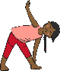  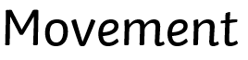 | -PE/Science Check the science pages for more information.  (Joe Wicks, Just Dance, GoNoodle or Jump Jam)
9:30-10:30 (60minutes) | 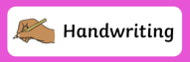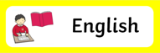 | See the English task set for you.  Complete handwriting Monday & Tuesday.  Spelling, punctuation and grammar. on Wednesday.
10:30-11:00  (30 minutes) |  | Have a snack!
11:00-12:00 (60 minutes) | 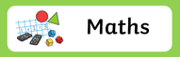 | See maths tasks for each day.  Spend 15 minutes on Doodle Maths.
12:00-1:00 (60 minutes) |  | Check each day for a task or read your own book!
1:00-1:30 (30 minutes) | 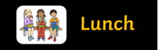 | Eat your lunch.

1:30 – 2:00 (30 minutes) |  | Have a snack and a stretch.
2:30-3:00 (30 minutes) |  | You Choose:  -Topic  -Science  -Computing. Eg Busy things, Scratch  - Cooking  - Music (practice an instrument or make your own one!)  -Art
3:00-3:30 (30 minutes) |  | What have you learnt & enjoyed today?  Tell a family member, record your daily thoughts into a journal for future reference or create a video diary.  Remember to be kind and let your light shine!

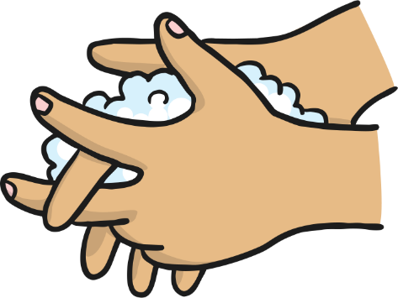
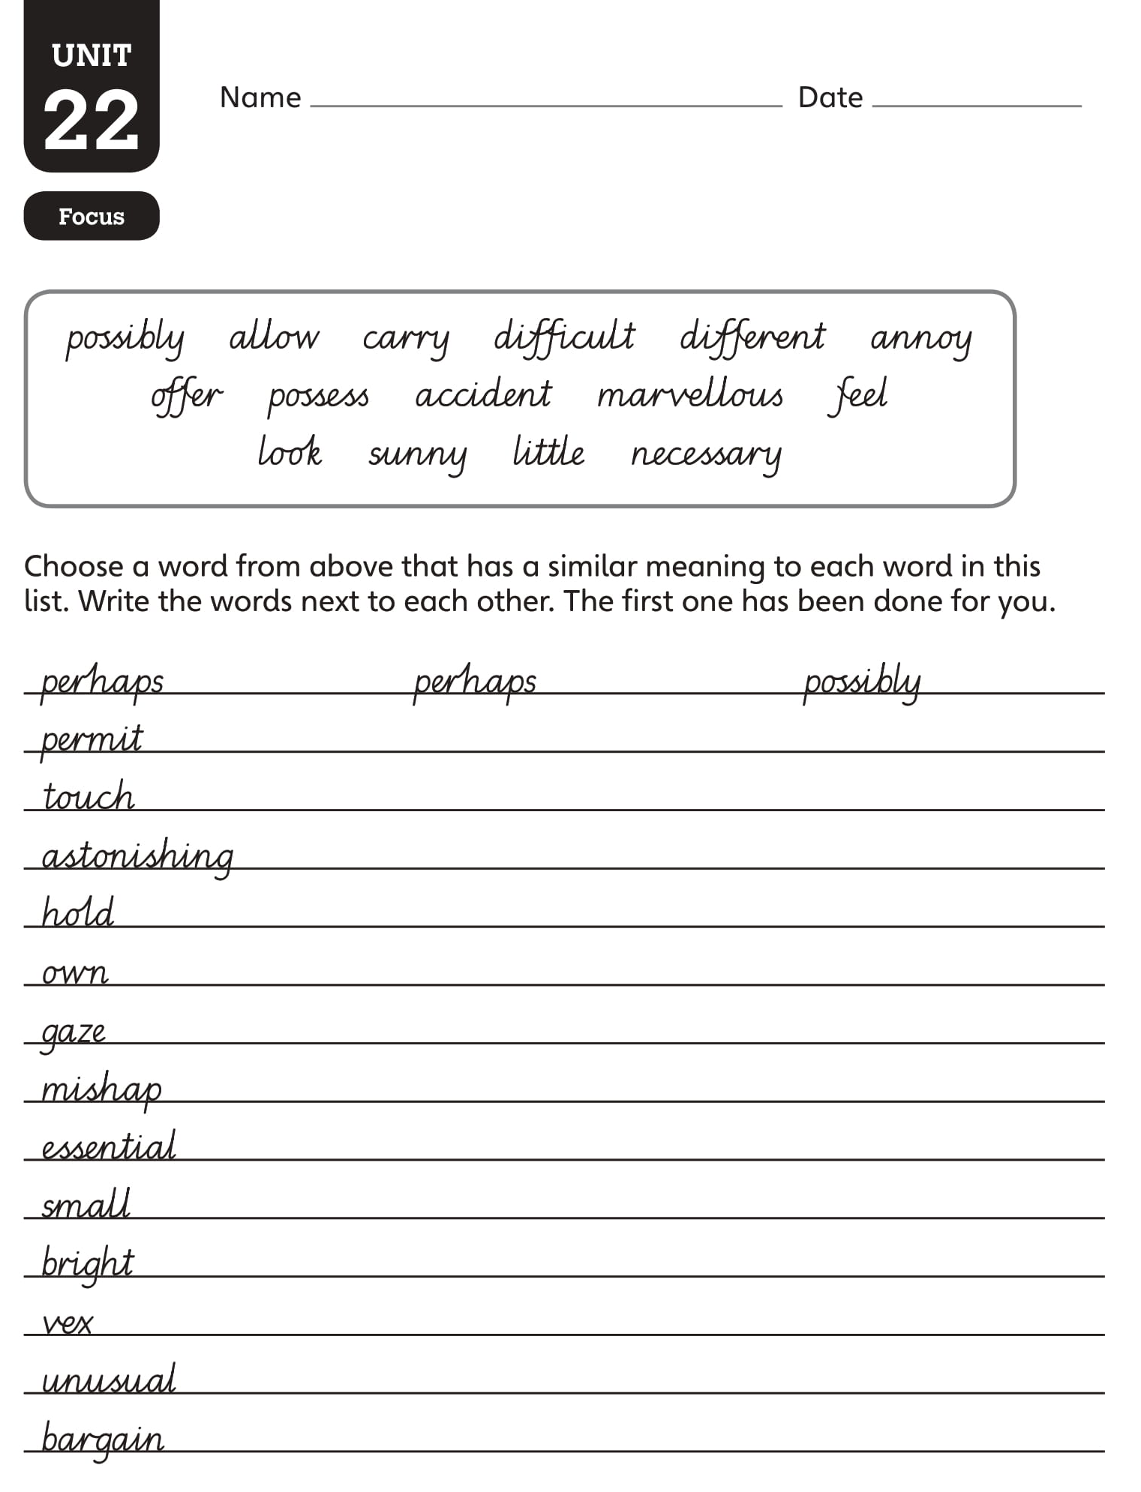
Remember to wash your hands throughout the day!
Monday
Year 6 - Handwriting
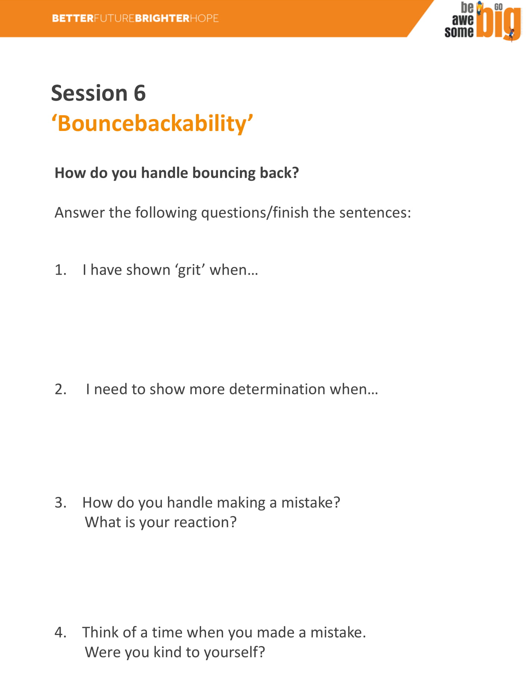
We will be continuing on from last week’s lessons about transitioning and how to deal with change.

Be Awesome, Go big
Monday
Year 6 - English
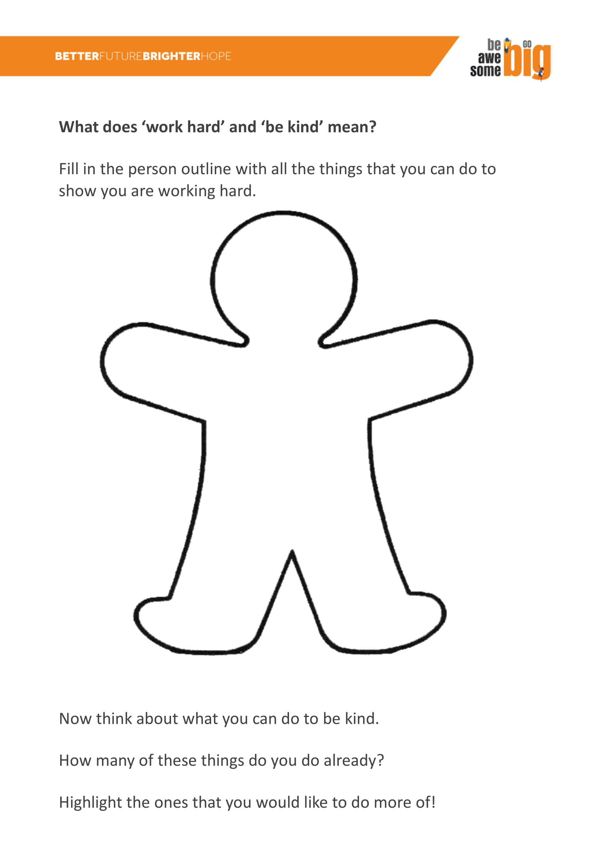
Monday
Year 6 - Maths
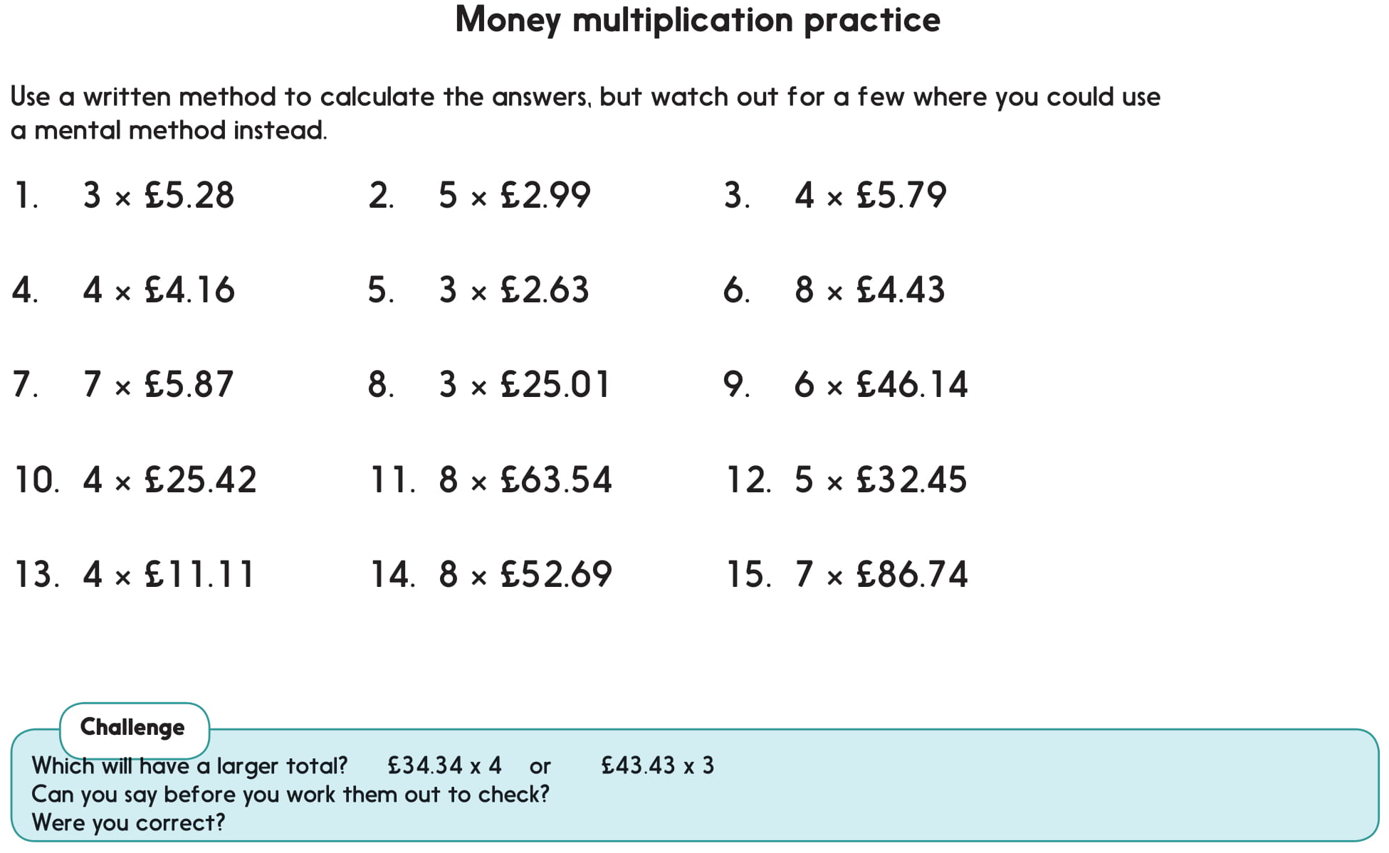
Investigation:
Choose a number from 3 to 9.

Choose one of these prices to multiply by your chosen single-digit number.

£45.19 £26.47 £53.28 £42.75

You are aiming for an answer as close to £200 as possible!

Repeat, with a different single-digit number each time.

Which answer was closest to £200?

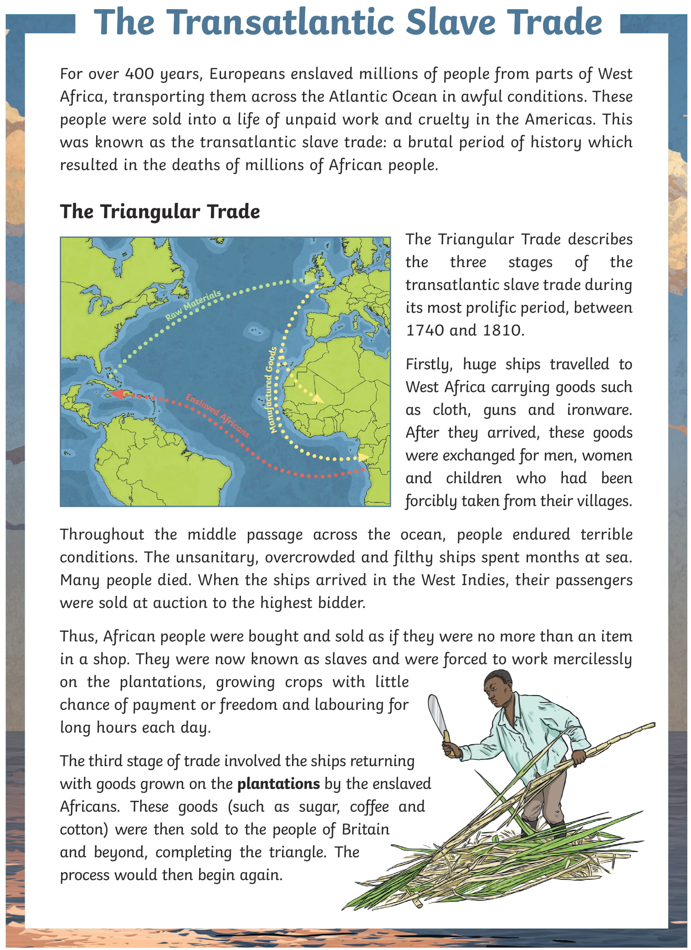
Monday
Year 6 - Reading
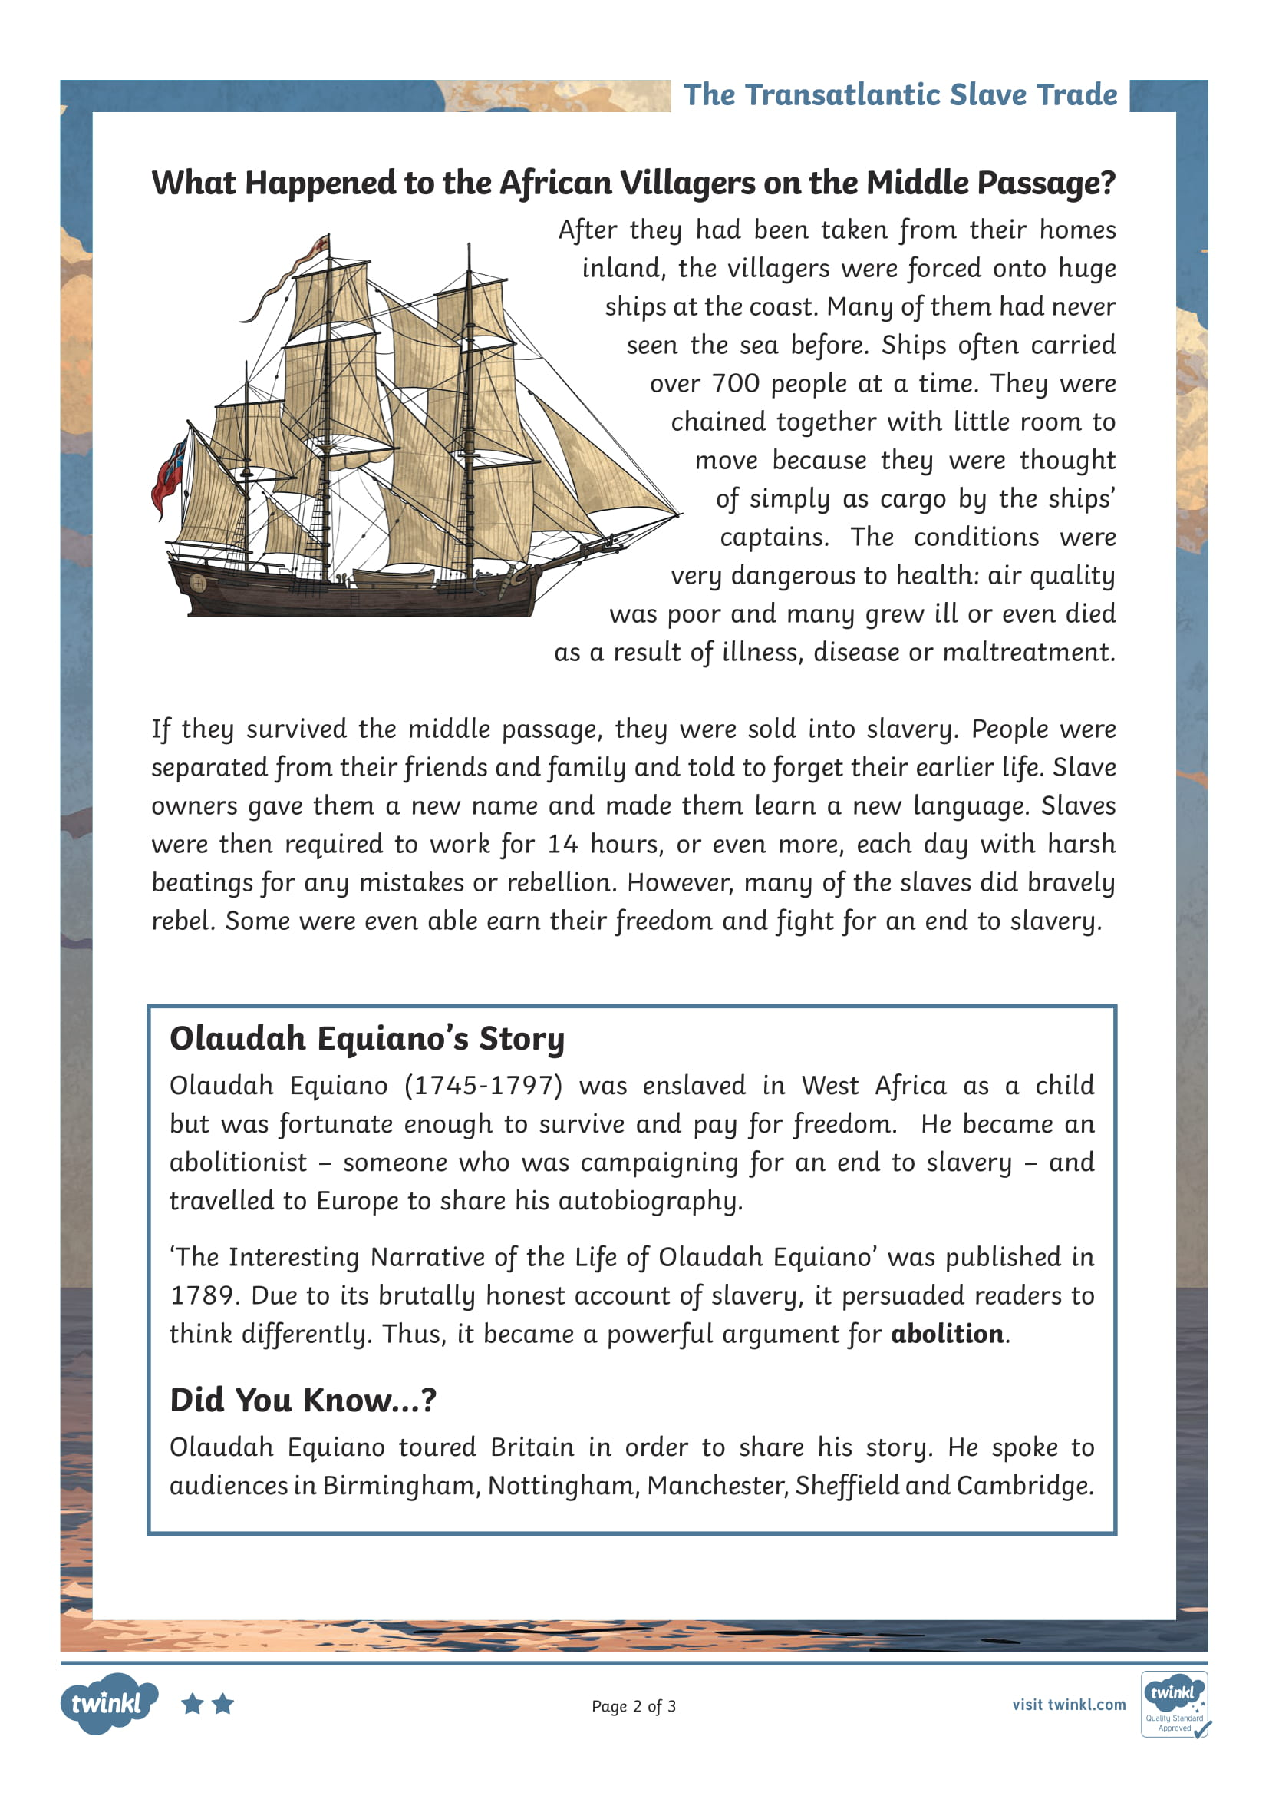
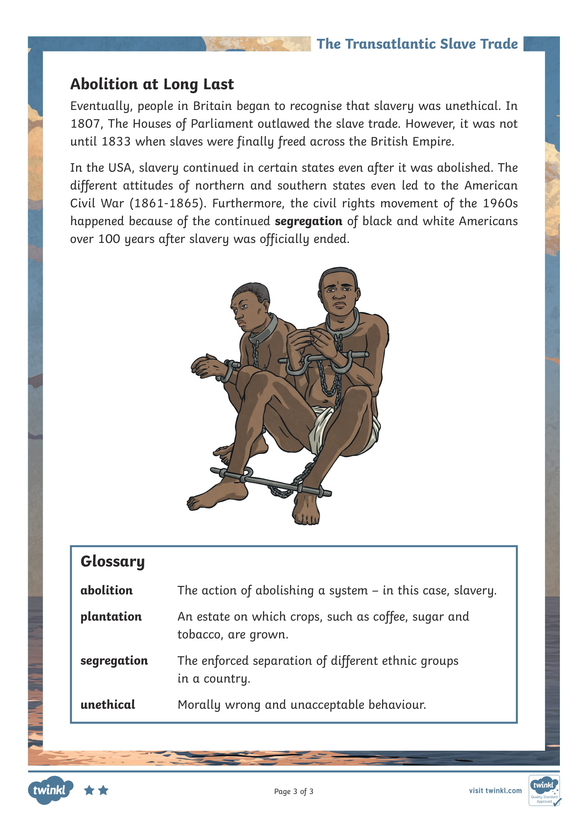

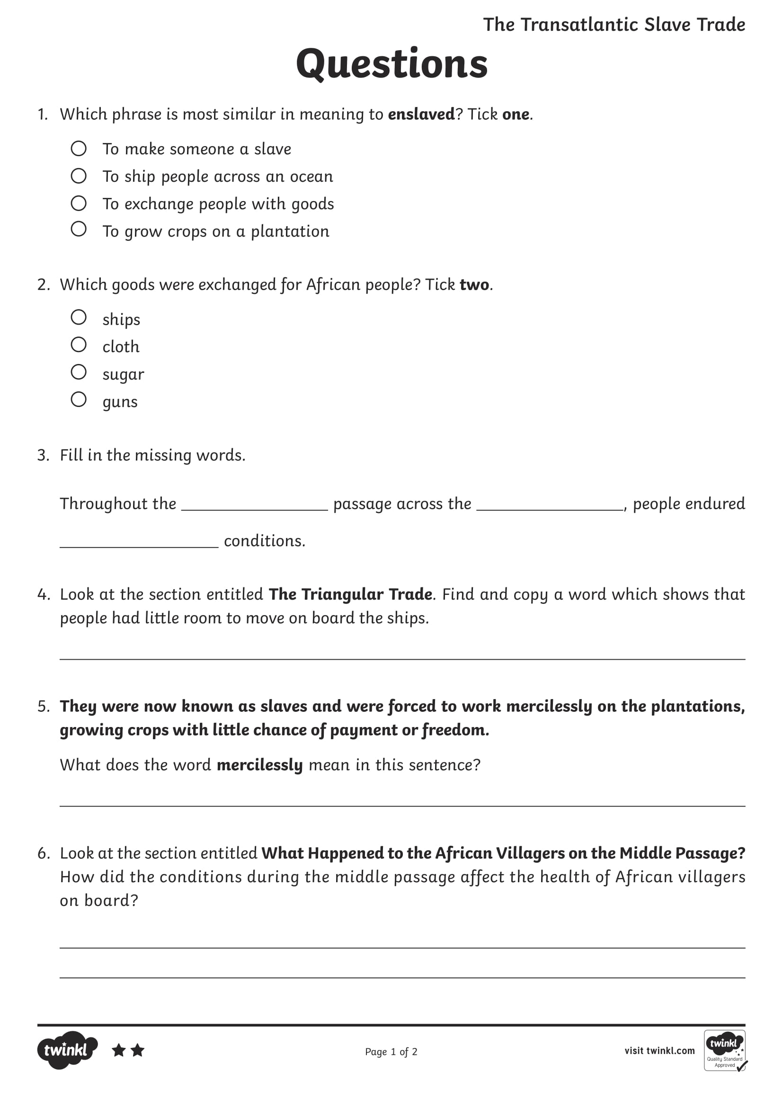

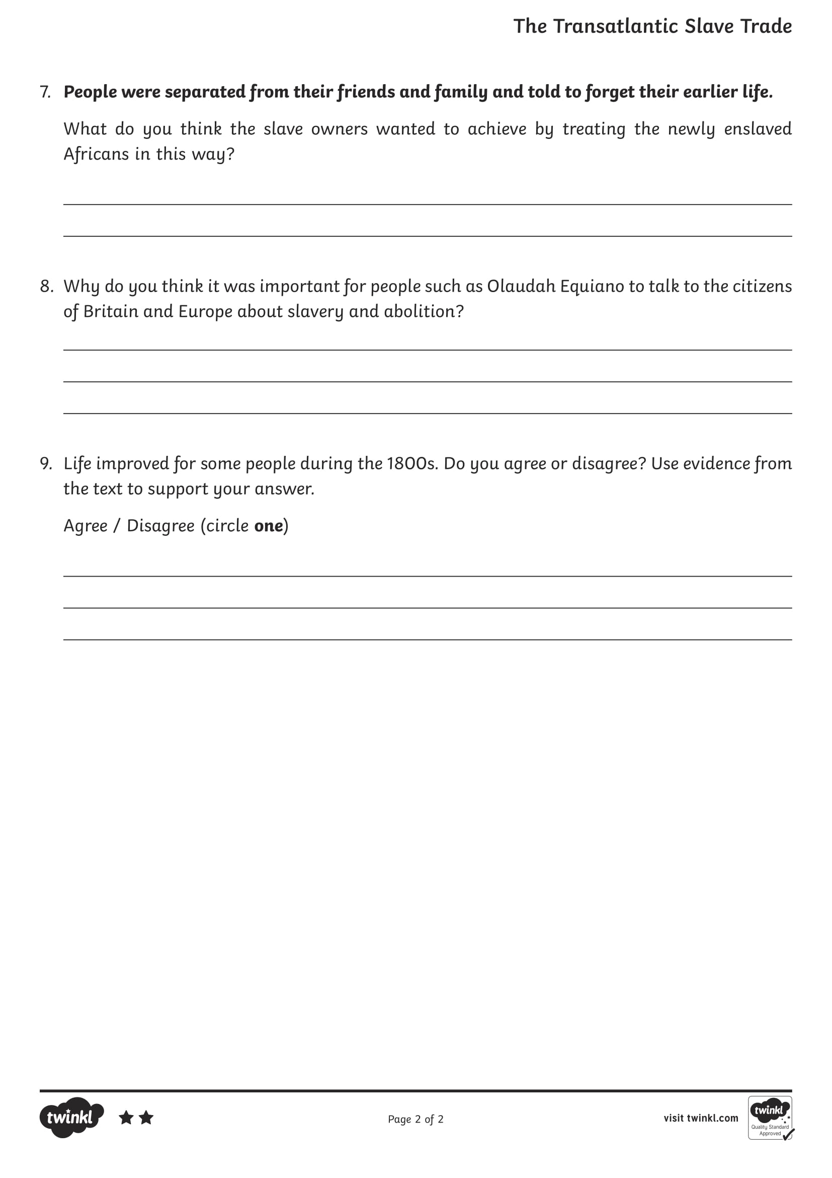

Tuesday
Year 6 - Handwriting

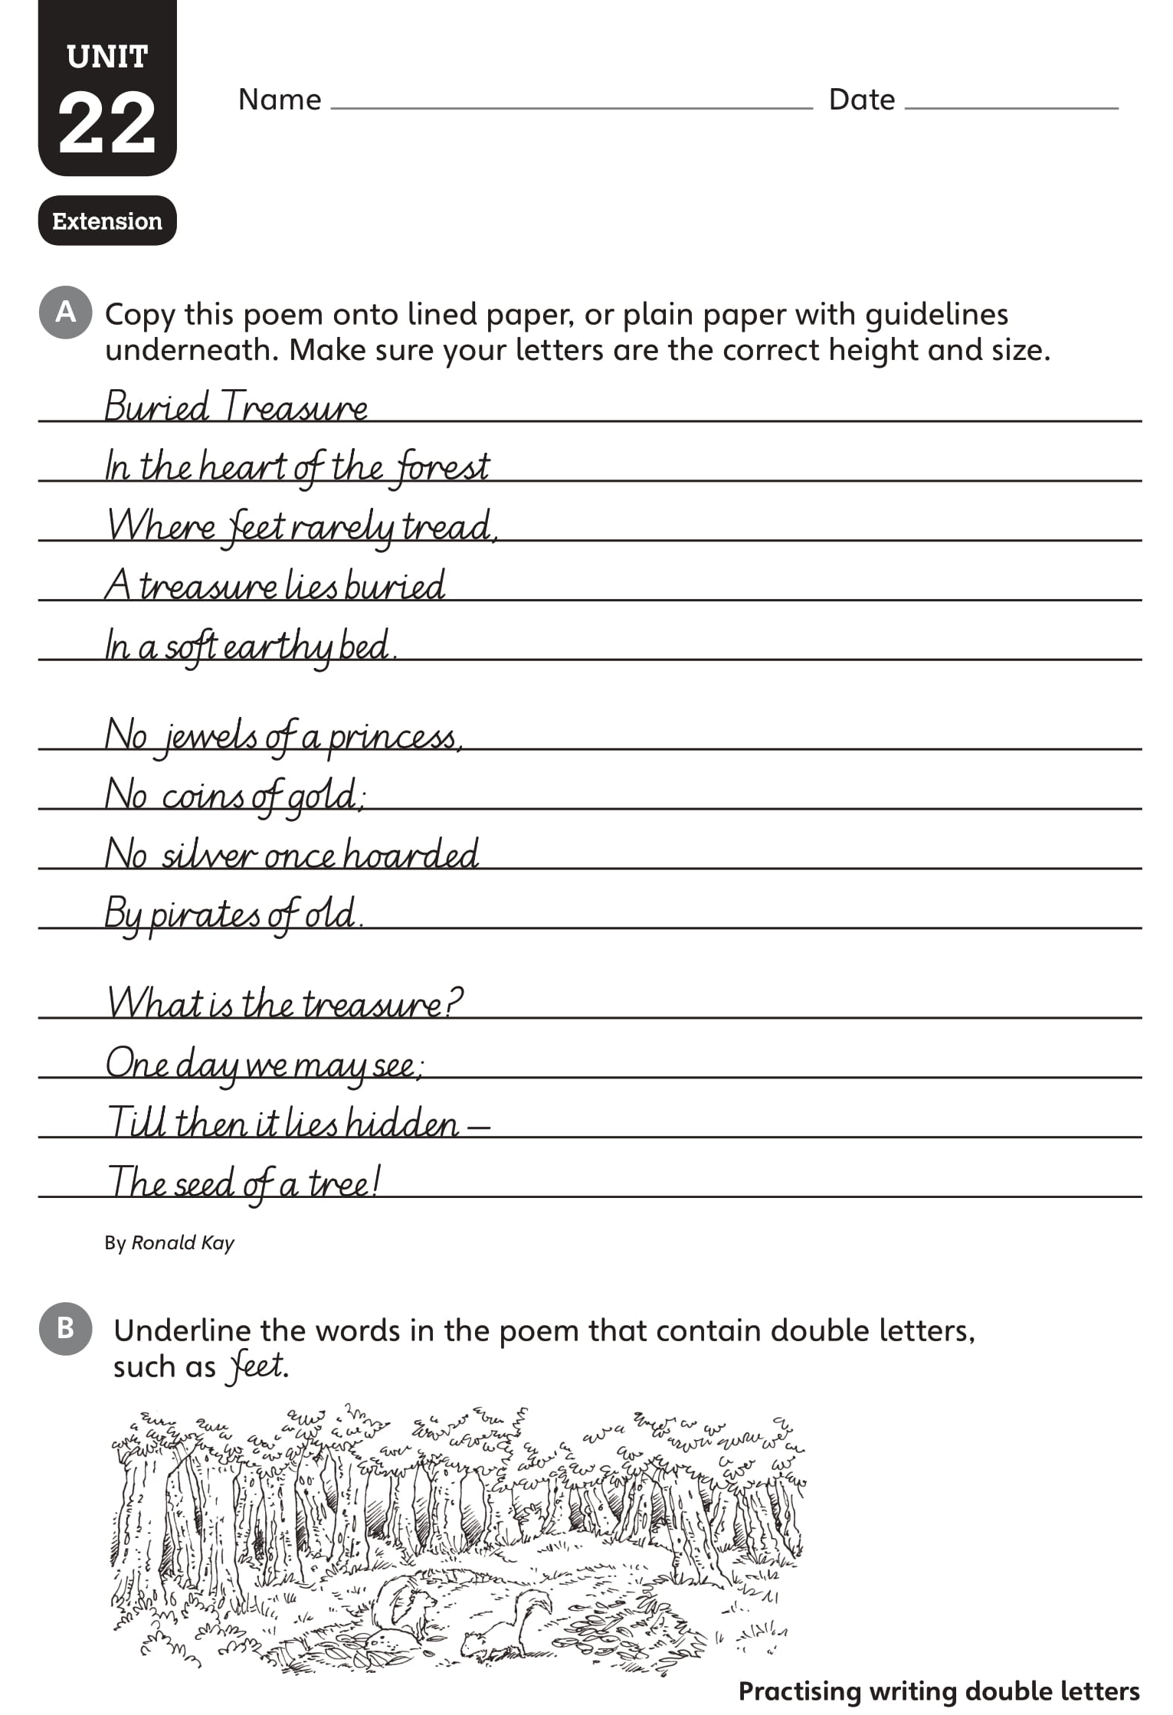
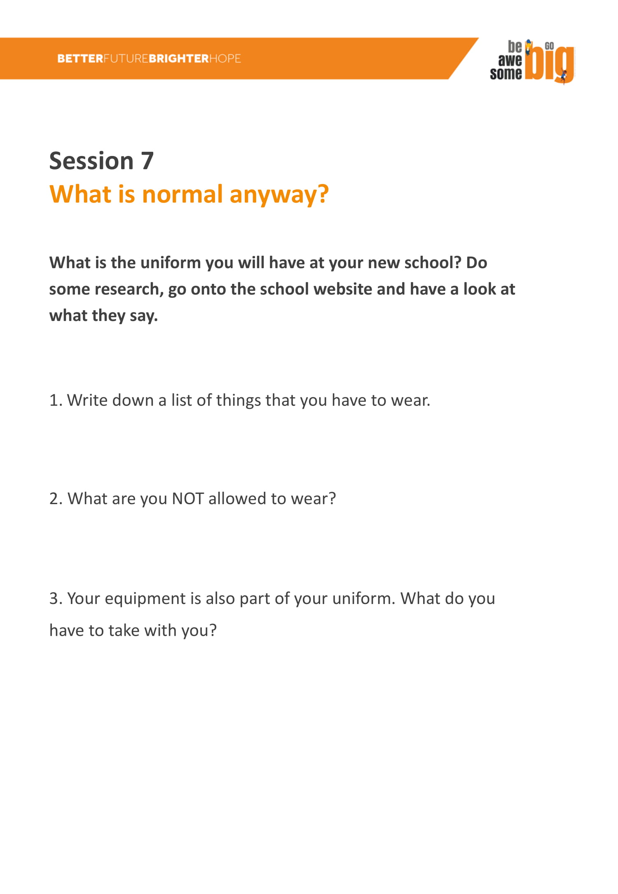
Growth Mindset
Tuesday
Year 6 - English
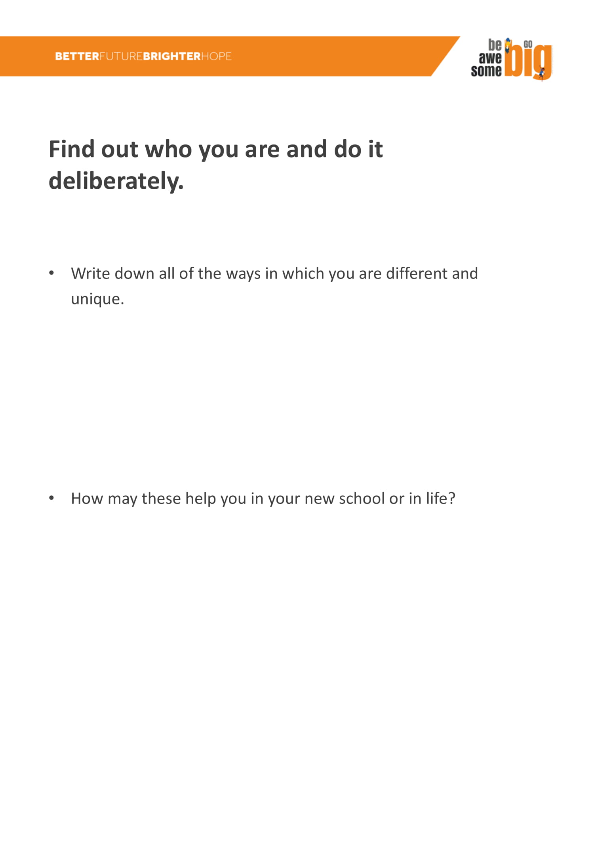

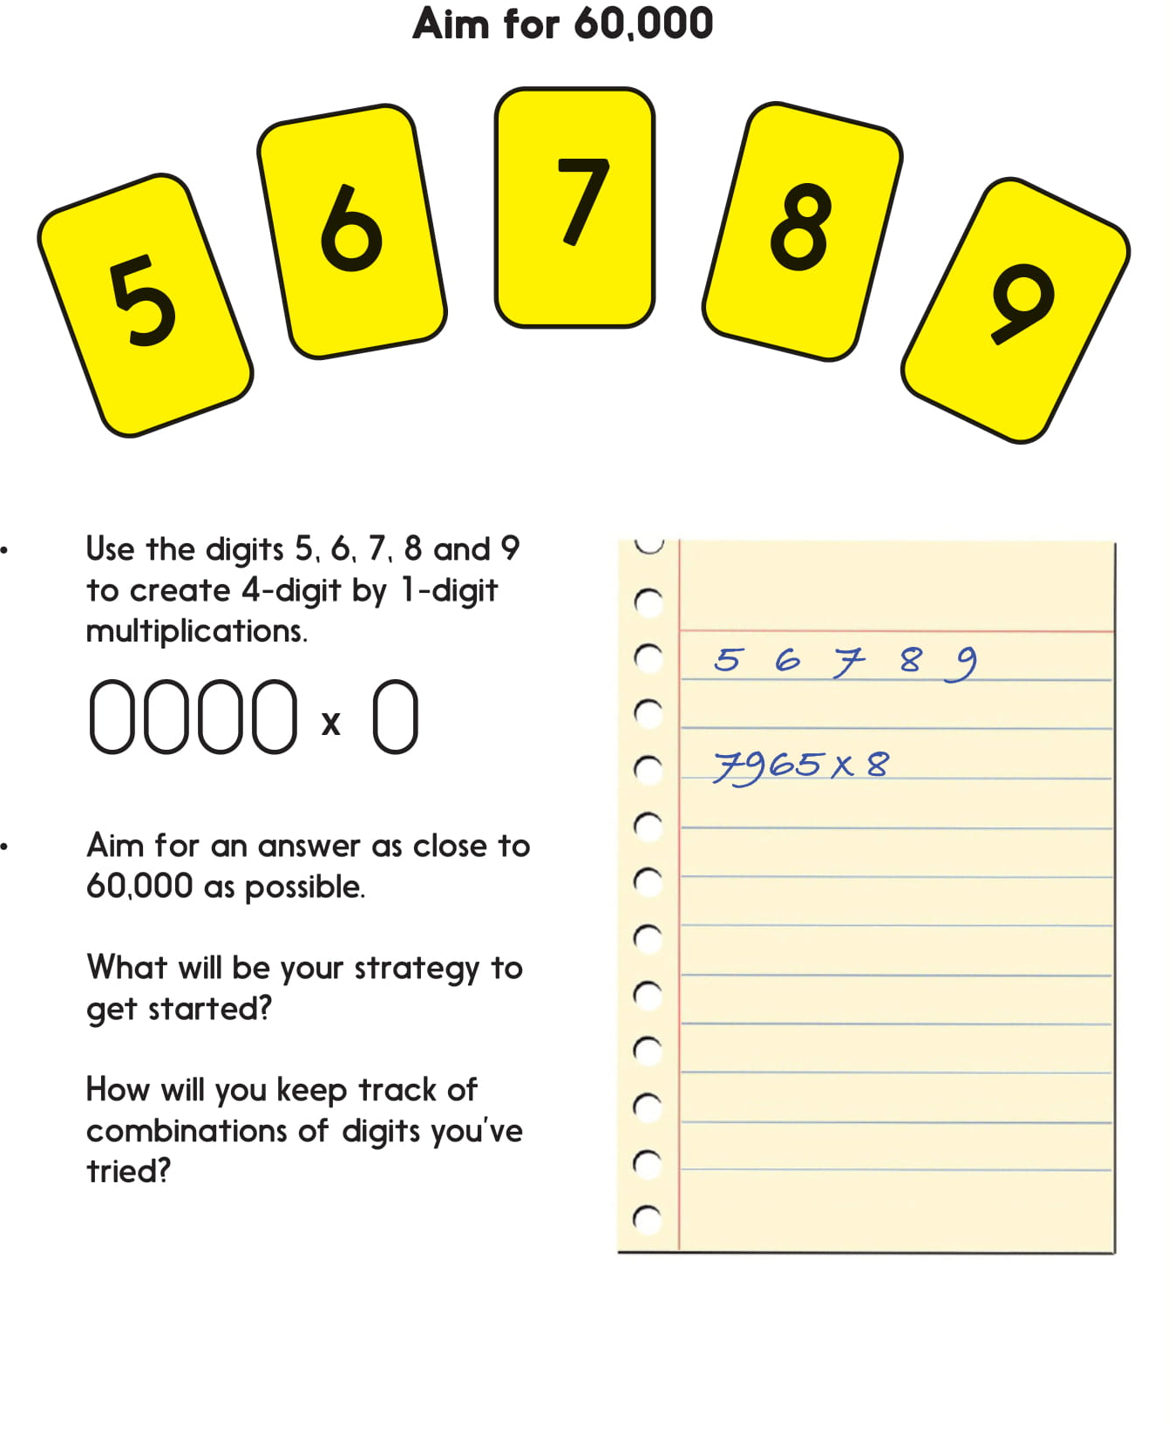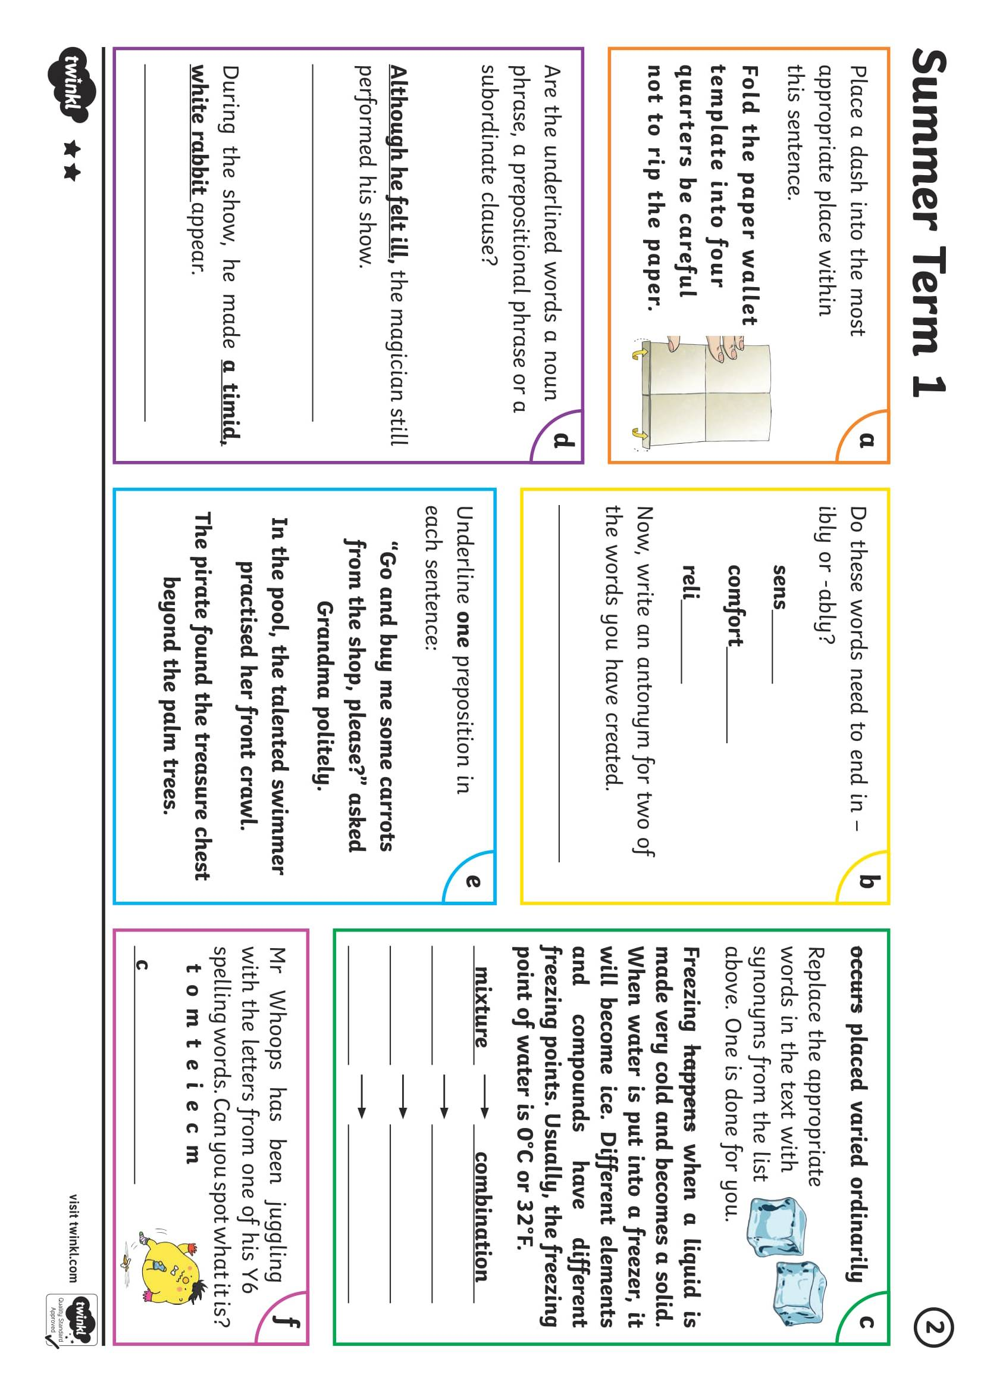
Tuesday
Year 6 - Maths
Wednesday
Year 6 - SPAG
Spag
Falling in and Falling out
Wednesday
Year 6 - English
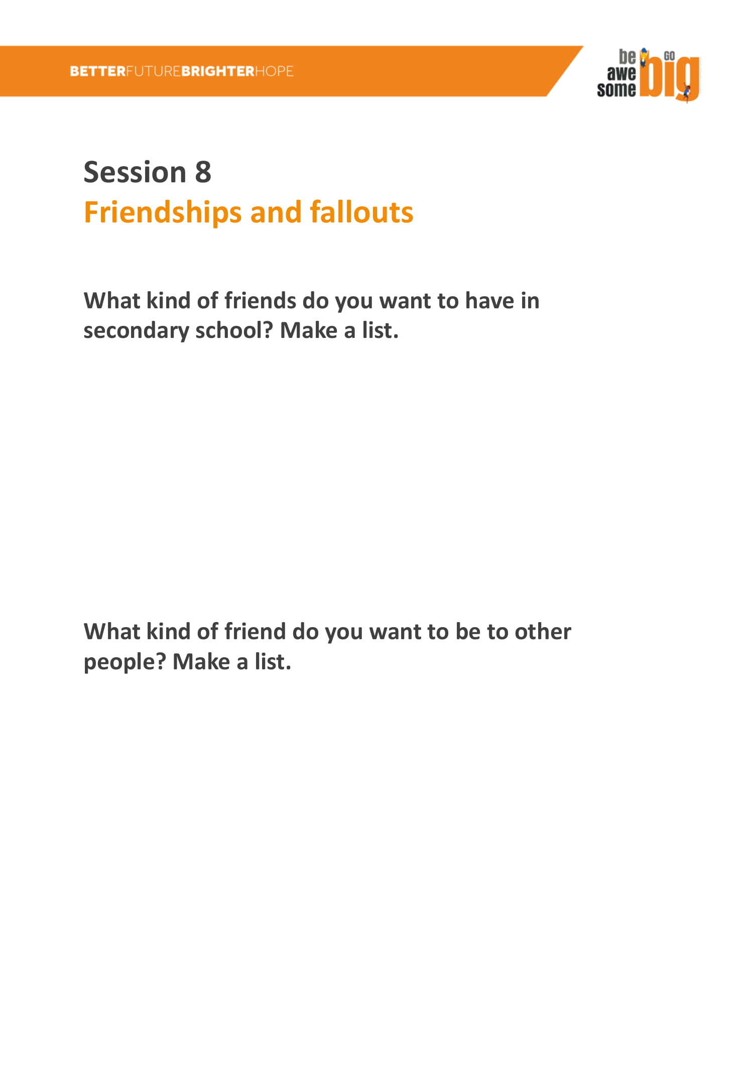

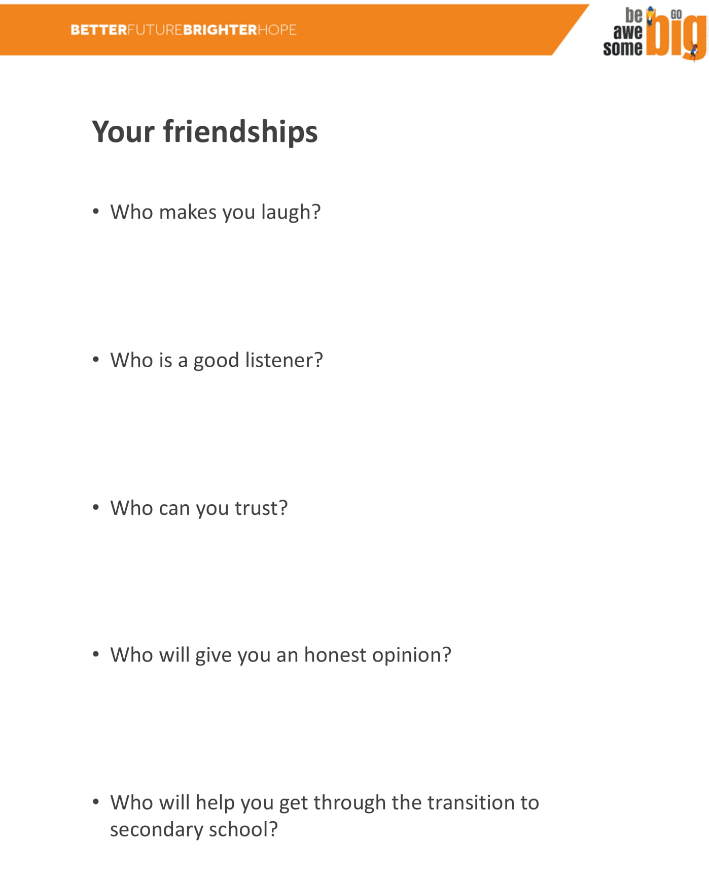
Wednesday
Year 6 - Maths

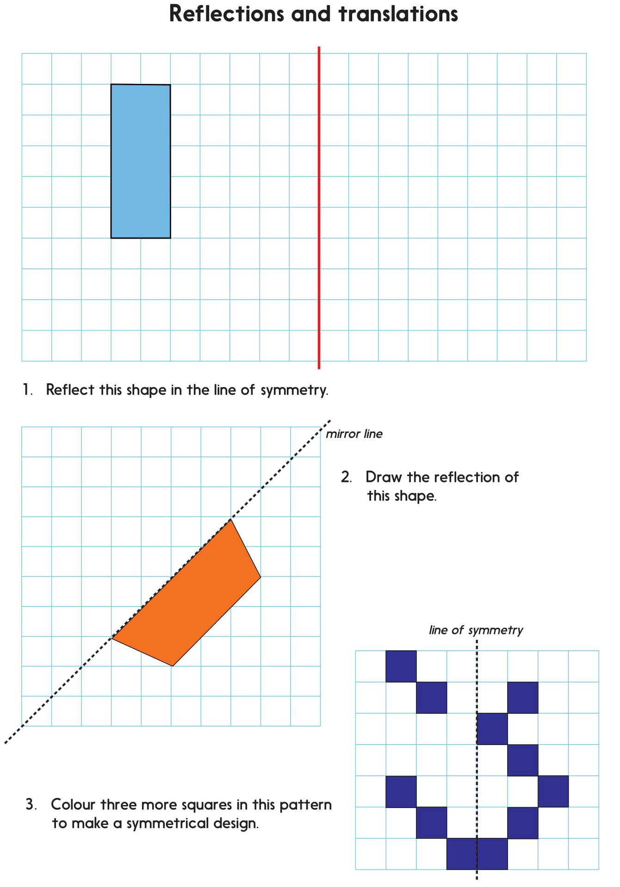
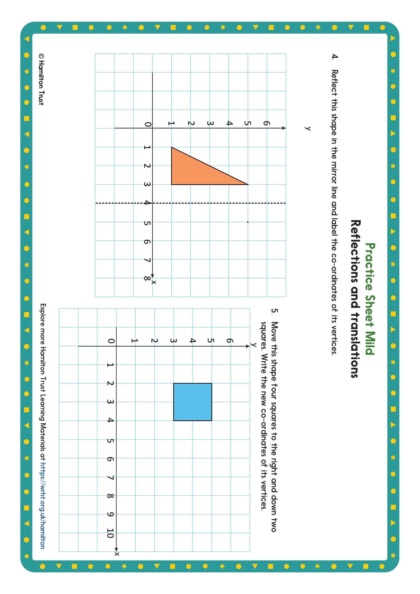
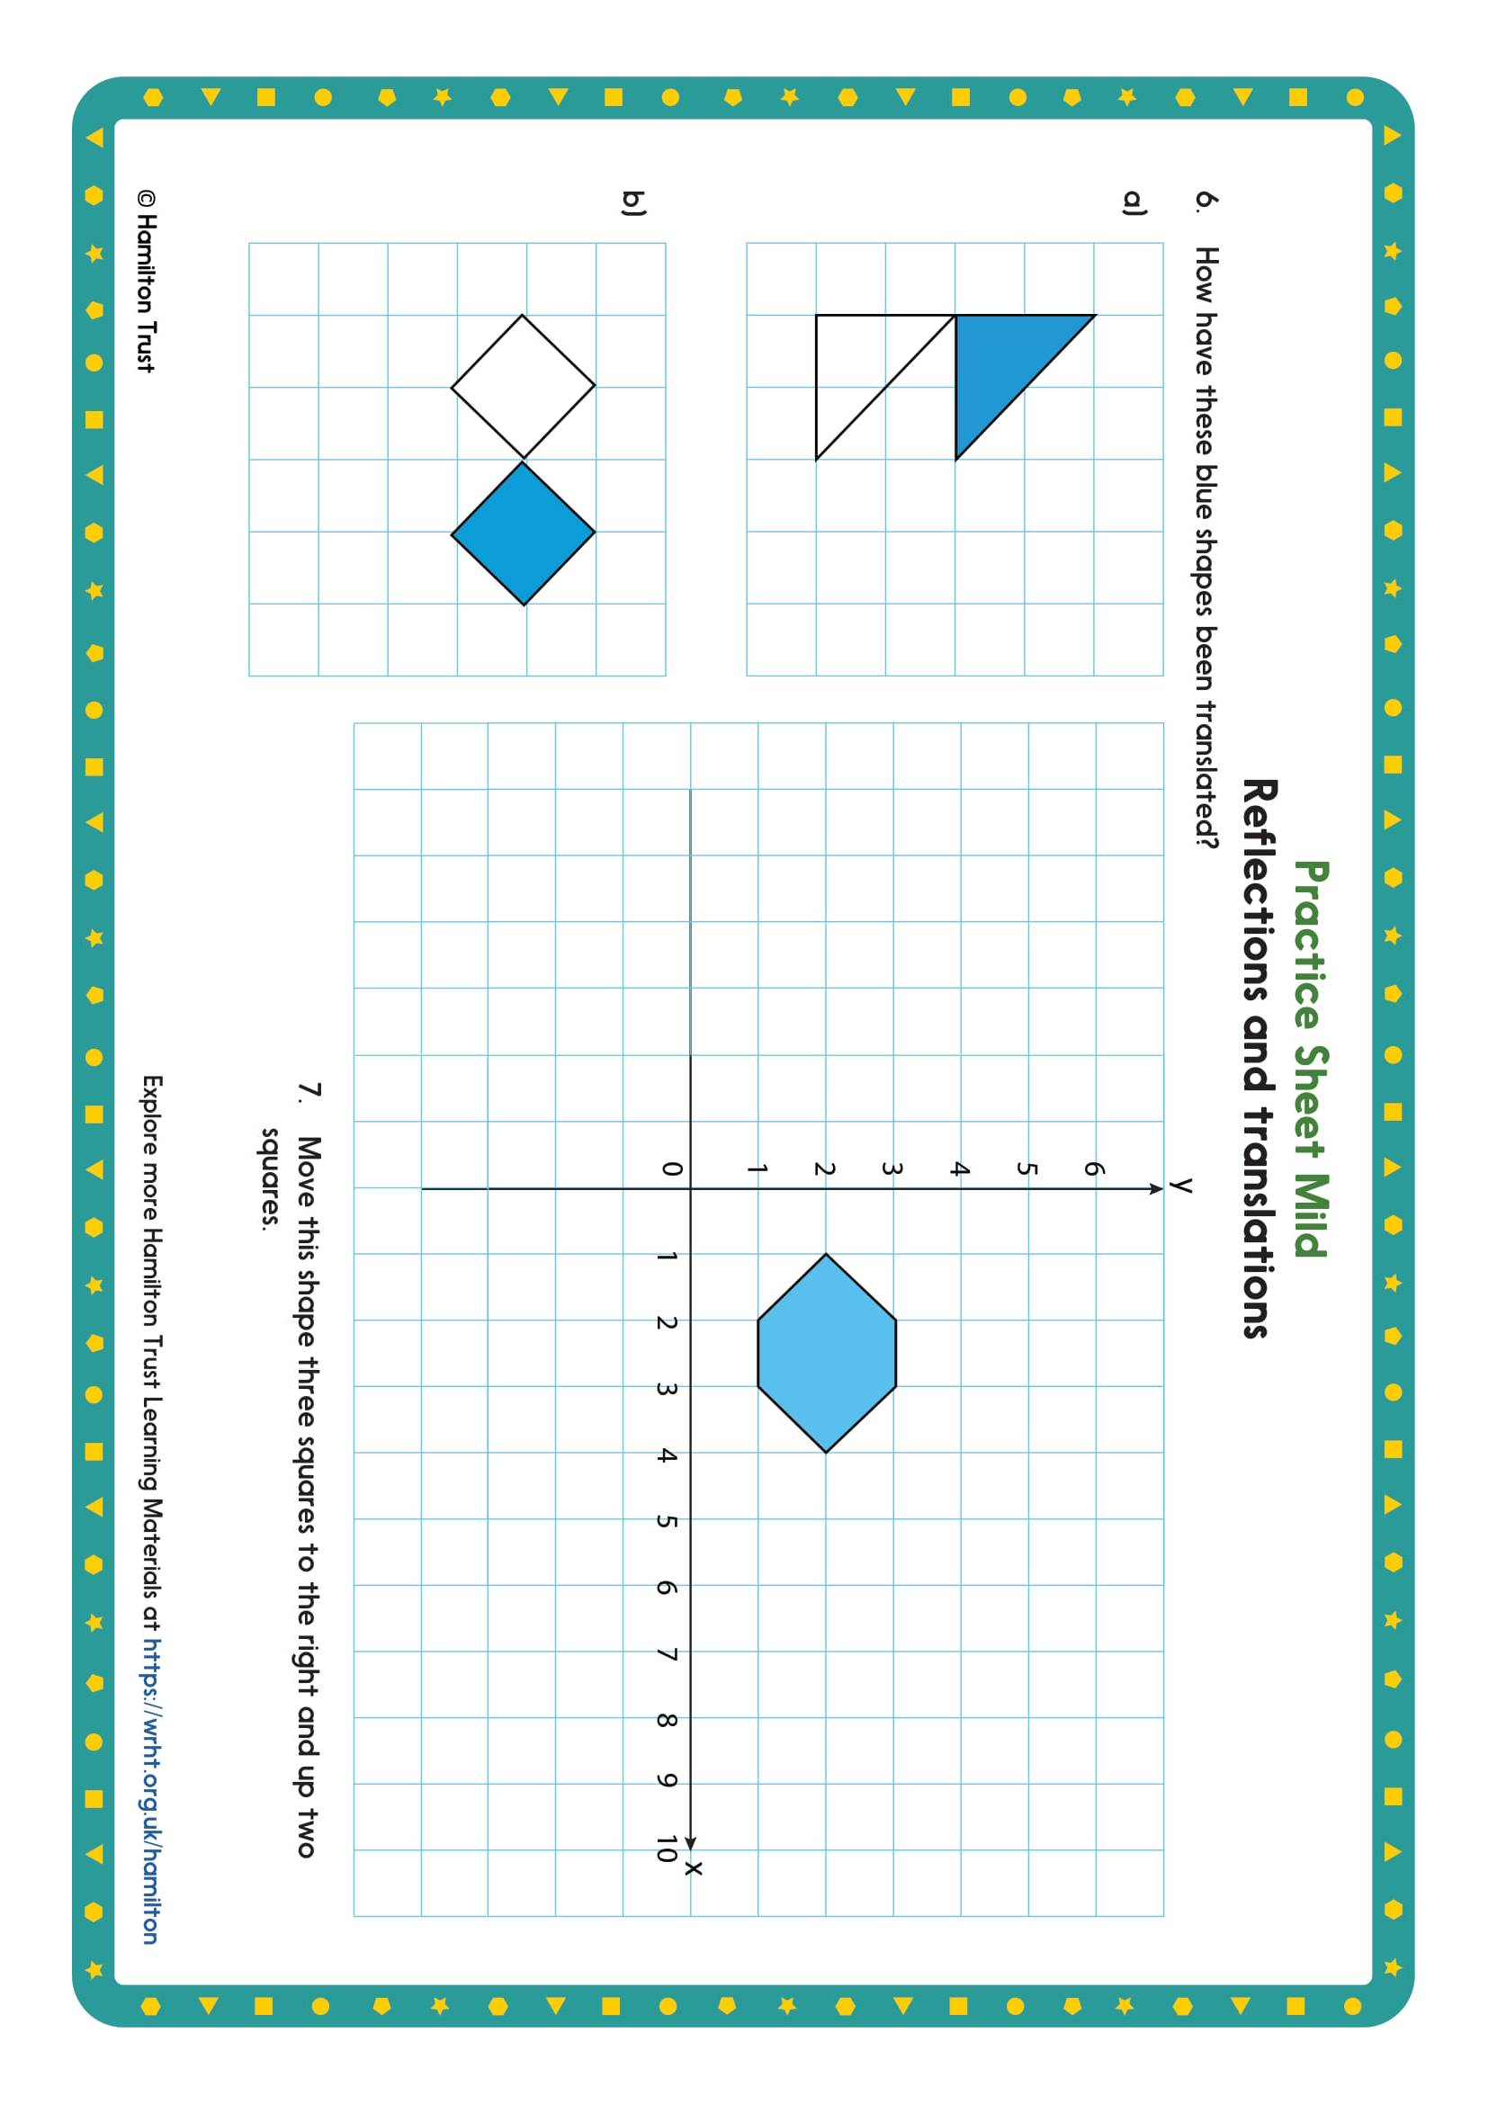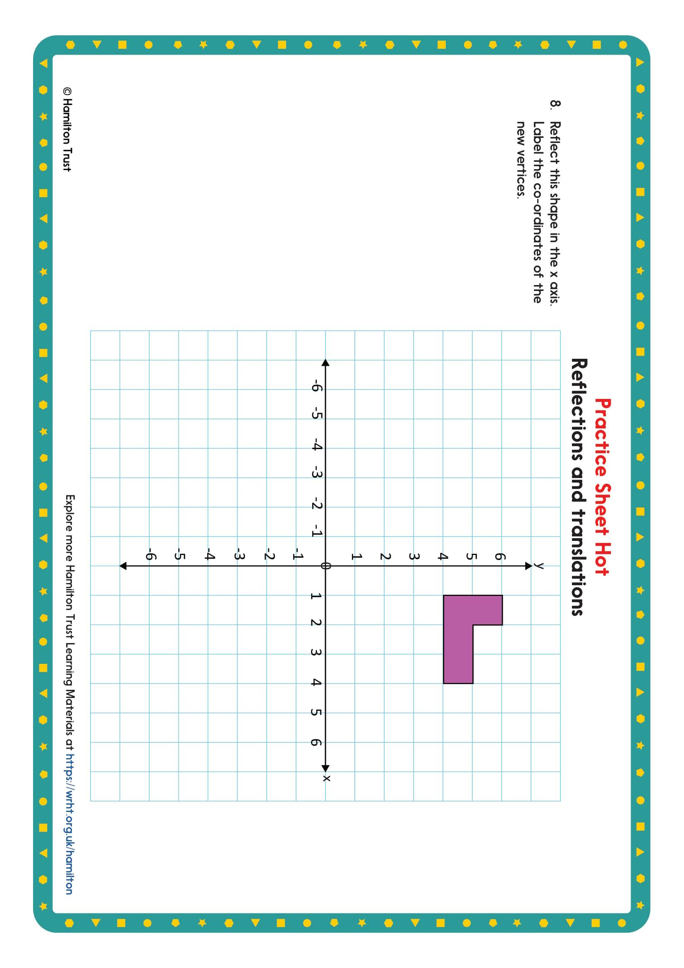
Wednesday
Year 6 - Reading

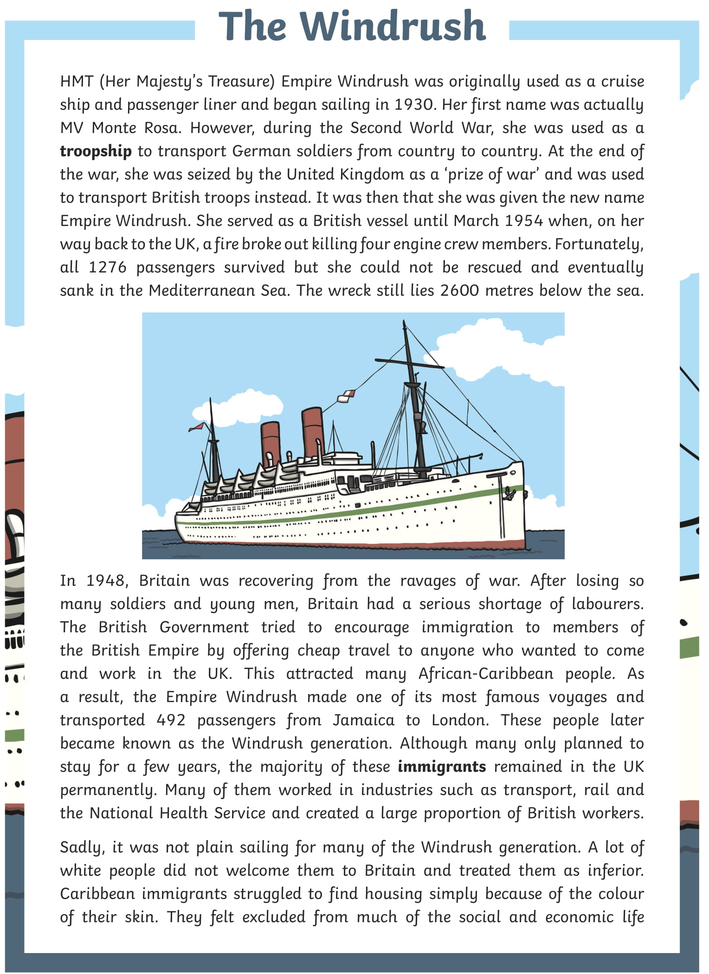
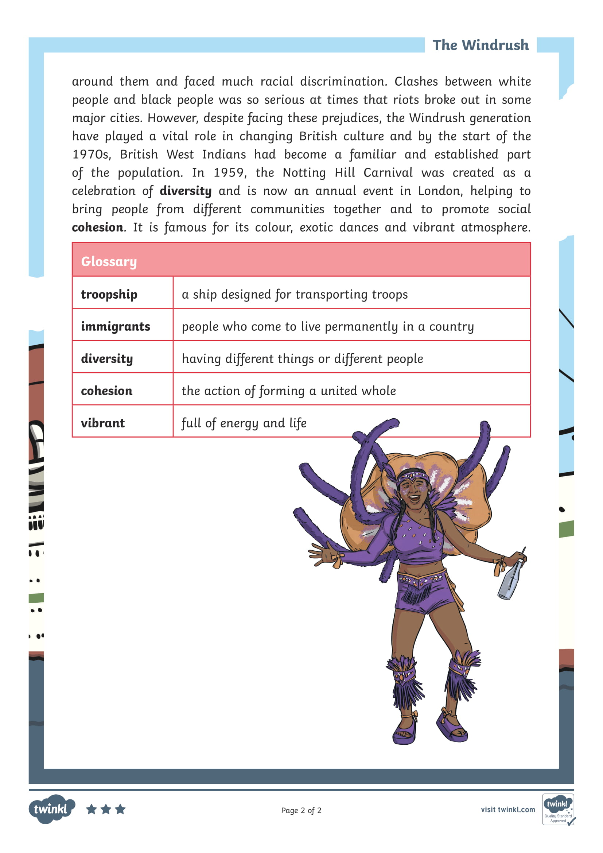

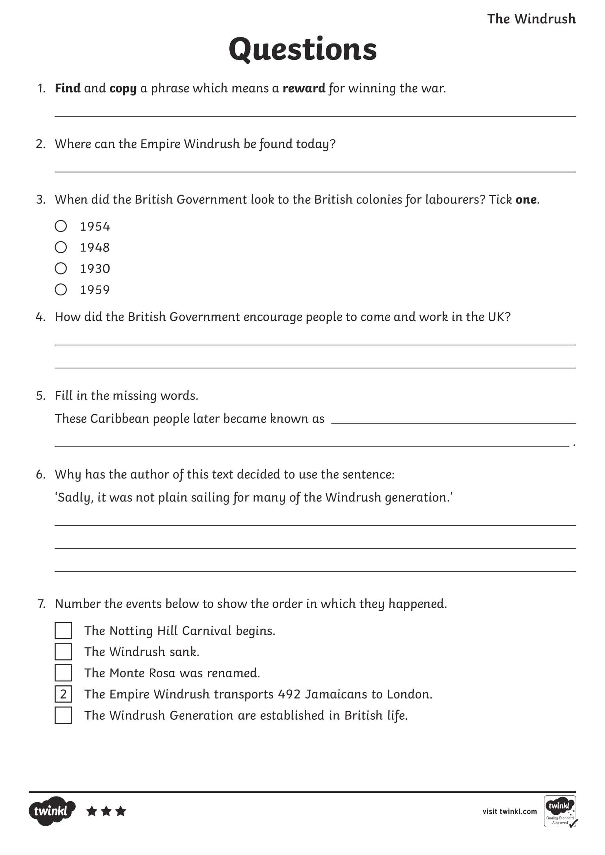

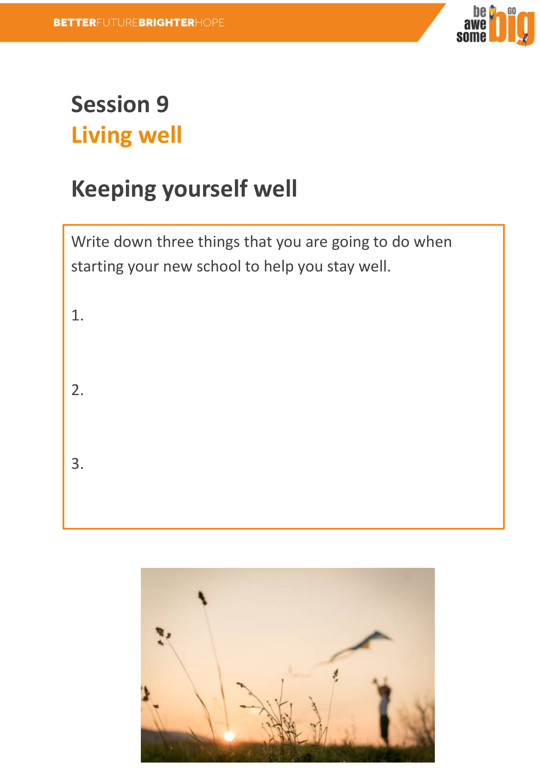
Keeping Well
Thursday
Year 6 - English

Properties of 3D shapes
Thursday
Year 6 - Maths

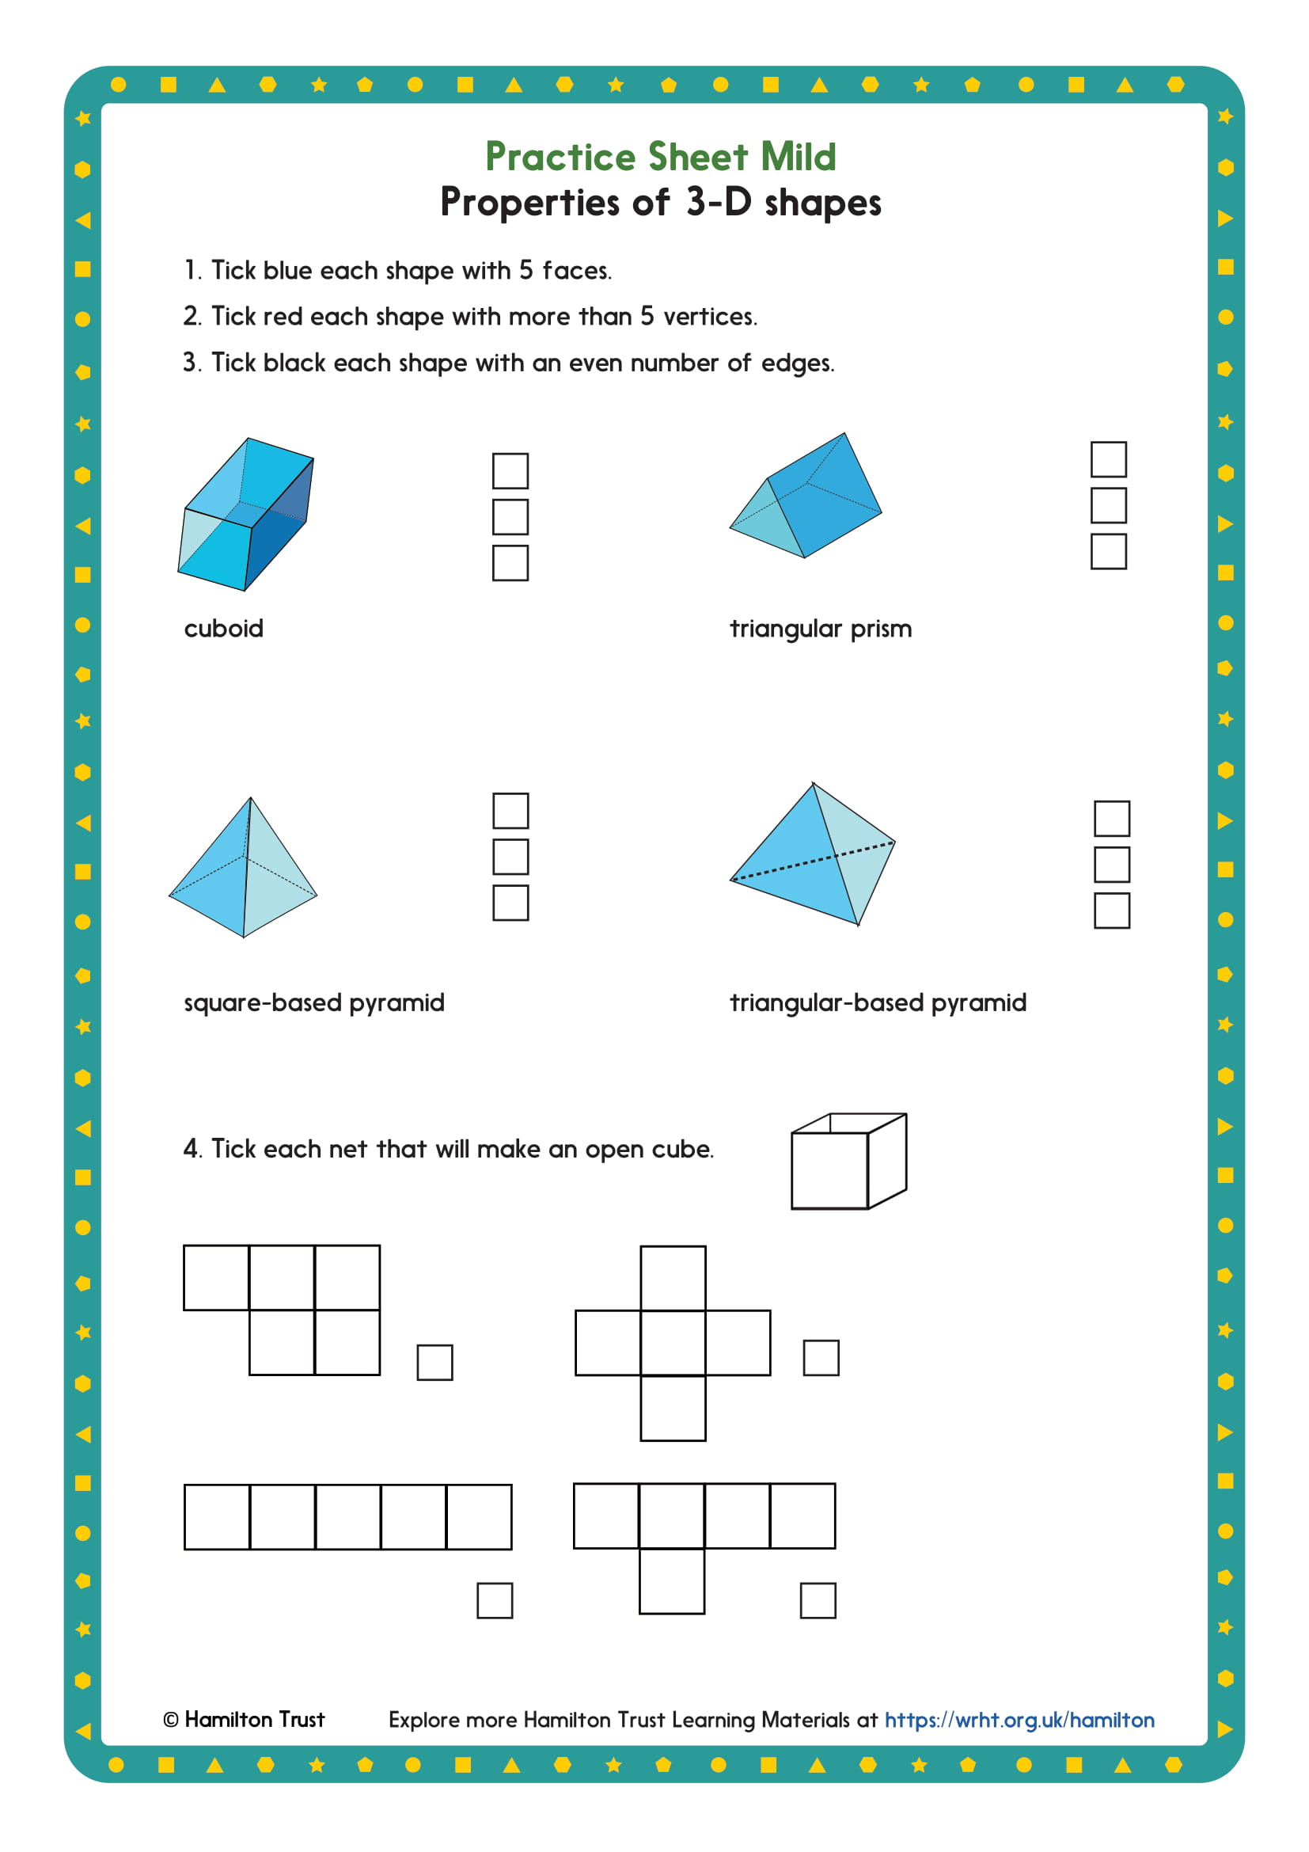

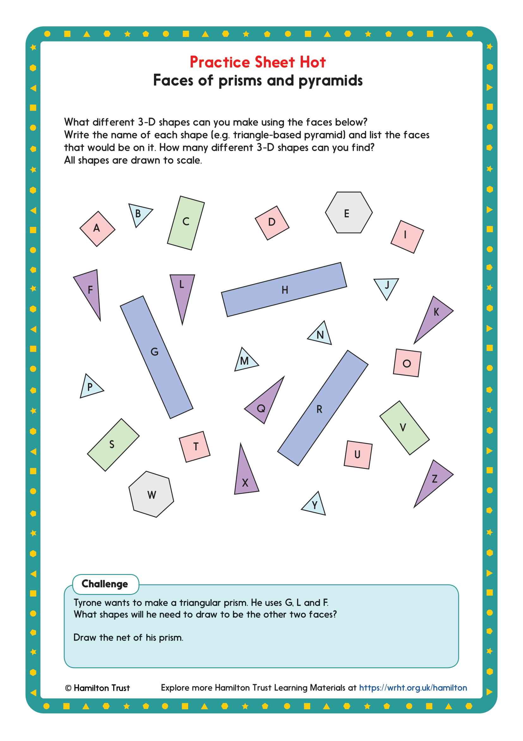

Word problems
Thursday
Year 6 - Maths

What do we call a circular-based pyramid?

_________________________________________

How many vertices does a pyramid with a pentagon base have?

_________________________________________

How many edges does a prism with pentagon ends have?

_________________________________________

True or false?
“A prism always has two parallel faces.”
“A pyramid cannot have any parallel faces.”

_________________________________________

Sketch the net of a cuboid with no ‘lid’.
_________________________________________
Idioms
Friday
Year 6 - English

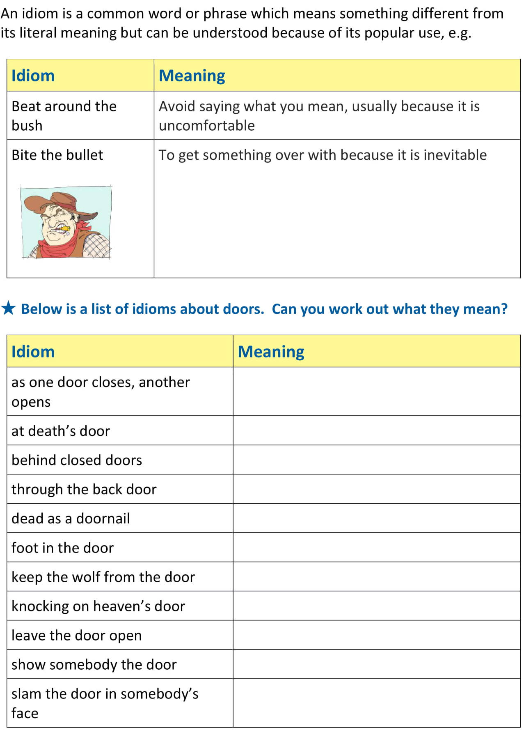
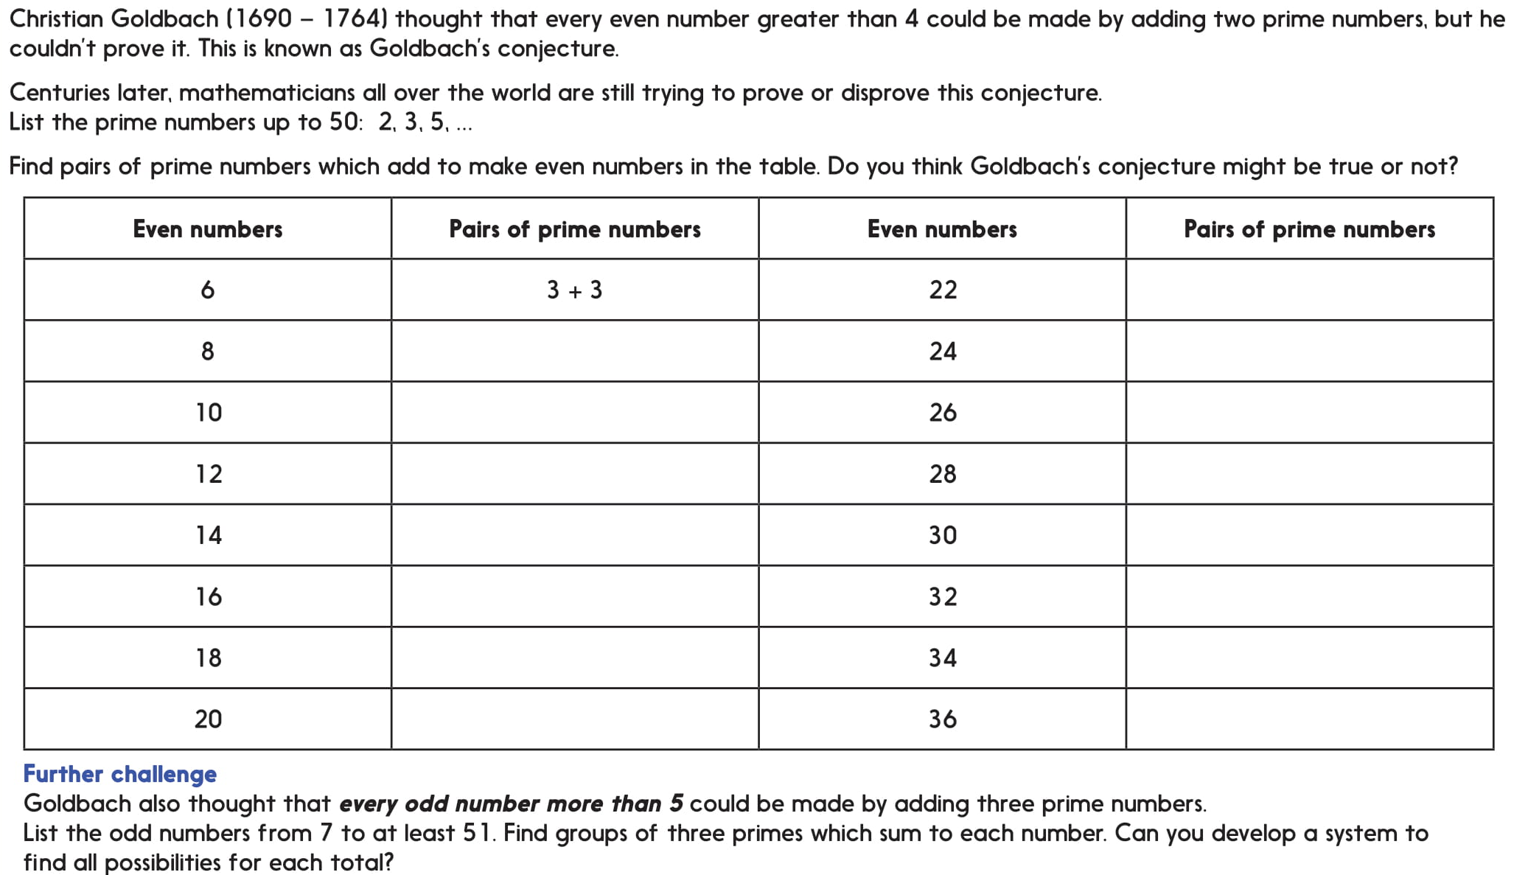
Investigation
Goldbach’s Conjecture
Friday
Year 6 - Maths

Word Problems

Prime numbers are often 1 more than or 1 less than a multiple of 6. Write the two prime numbers of which this is not true.
___________________________________________________

Explain why 1 is not a prime number.

Write 30 as the sum of prime numbers in two different ways.

True or false: The lowest common multiple of two prime numbers, a and b is always a x b.

You choose!
Afternoon
Year 6 - Choosing

Choose an activity, in any order you like.
You can create your own version of any task or activity, including questions for your classmates, friends or family.

Other ideas include:

Write a journal for your day or week.

Write a book report. Remember your audience. Would you recommend the book? Why? To whom?

Make a list. Lots of You Tube videos are lists of things. What would your top ten video be about? Can you write a script for it?

Make a quiz. It could be any kind, maths, history, films, videogames, emoji. You decide.

Create a puzzle.

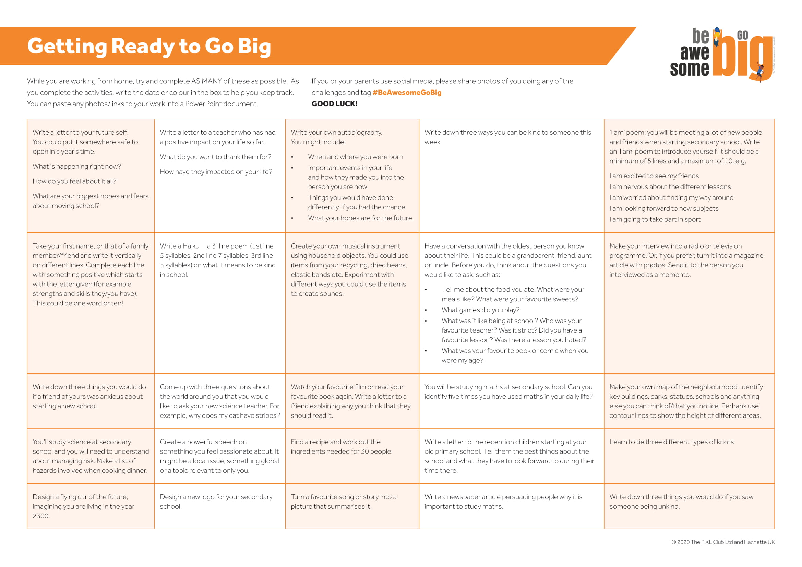
Science
Perfect Pinchers
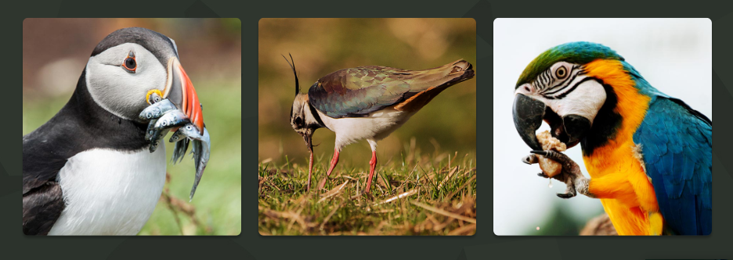
Take a good look at the 3 images above. The images show a puffin, a lapwing and a macaw. Come up with as many similarities and differences as you can.
If you get stuck, think about:
- appearance
- what they do
- where they might be found
- the title of this page!
Now, decide which one is the odd one out and why. You could have more than one answer but you must give a reason for each answer you give. You CANNOT be wrong if you can justify your answer.
Extra information:
Some puffins shed part of their colourful beaks in winter, leaving a smaller, less colourful one behind that will grow through the rest of the year. Puffins dive down to great depths to catch fish, their staple diet. Their beaks have backward pointing spines so they can store rows of fish in their mouths without swallowing them. They also use their beaks as picks and shovels to build burrows when they return to land to breed in spring. The lapwing bird is found on farmland across the UK. Their long pointed beak acts like tweezers to precisely pick up small insects and worms. The macaw is a type of parrot and has a very hard, strong beak which can crack open nuts. They like to chew on things like trees to keep their beaks healthy.
Most birds are insectivores, that is, they eat insects, but across the world birds can be found that eat meat, plants and fruit. A bird's beak is actually an extension of its skull, and you can find nostrils on the upper beak. The beak itself is made of a hard, keratin substance, similar to our fingernails.
Children’s Stories Emoji Quiz
Can you name the fairy tales titles from these emoji?

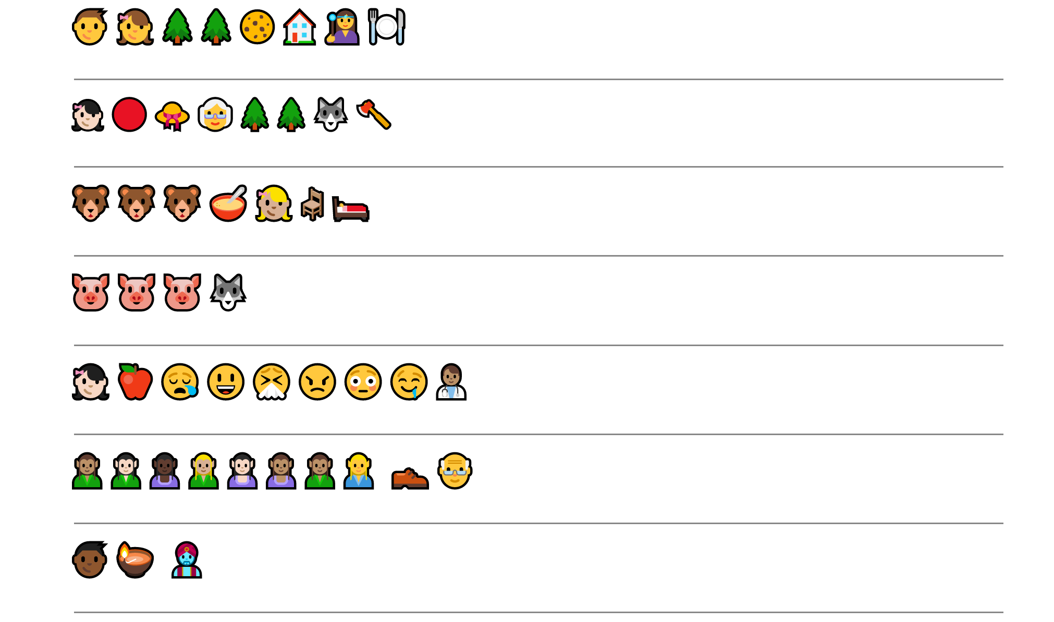
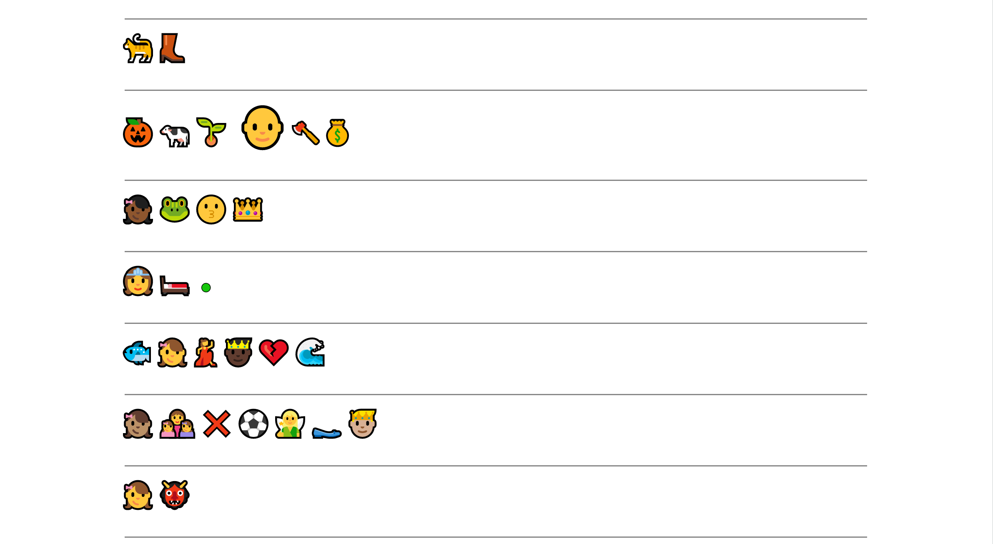
Colouring page!
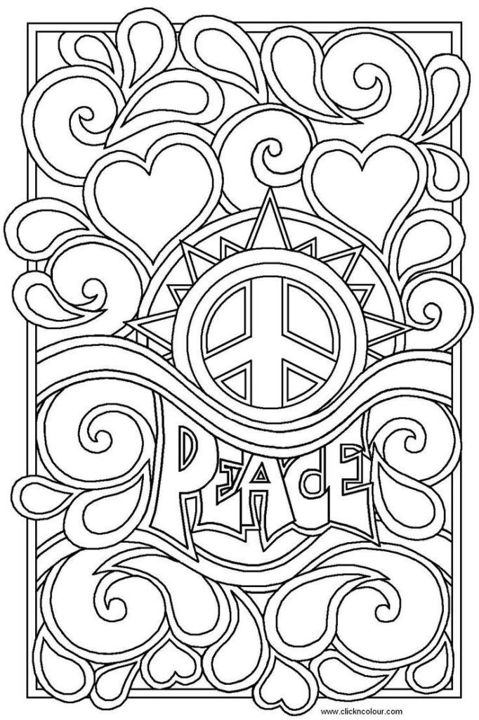
Word ladder puzzles

Each line is a new word. Change ONE letter from a word to make the next word. Use the clues to help you.

G | R | E | E | N | Summer colour
G | R |  |  |  | Wanting everything
 | R | E |  |  | Heavily wooded
T | R |  |  |  | More than one tree
 | R | E |  |  | Curl of someone’s hair
 |  |  | S | S | Old fashioned salad plant
C | R |  |  |  | Crude
G | R | A | S | S | Dad’s favourite plant

C | O | L | D
 |  |  |  | Twisted threads
 |  |  |  | Has meaning
 |  |  |  | An invertebrate
W | A | R | M

Word ladder puzzles
Change one letter each time to make the next word!

Only two clues this time!
R | E | A | D
 |  |  | D
B
B | O | O | K

Can you make your own word ladder puzzle?
You can give cryptic clues, some letters or a combination of both!

Extra Maths! Problem solving and reasoning questions

The centre of a square has co-ordinates (3, 1) and one vertex at (-1, 5). What are the co-ordinates of its other three vertices?

________________________________________________

A triangle with co-ordinates (-2, -2), (-2, 3) and (1, -2) is translated 6 grid squares to the right and 5 up. What are the co-ordinates of its new position?
_______________________________________________

A pentagon with vertices at (4, 7), (6, 2), (2, 2), (2, 6) and (6, 6) is reflected in the y axis. Write the co-ordinates of its new position.

