Time | Timetable | Activities
9:00-9:30 (30 minutes) |  | -PE/Science Check the science pages for more information.  (Joe Wicks, Just Dance, GoNoodle or Jump Jam)
9:30-10:30 (60minutes) | 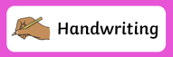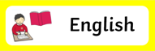 | See the English task set for you.  Complete handwriting Monday & Tuesday.  Spelling, punctuation and grammar. on Wednesday.
10:30-11:00  (30 minutes) |  | Have a snack!
11:00-12:00 (60 minutes) |  | See maths tasks for each day.  Spend 15 minutes on Doodle Maths.
12:00-1:00 (60 minutes) | 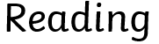 | Check each day for a task or read your own book!
1:00-1:30 (30 minutes) |  | Eat your lunch.
YEAR 6 HOME LEARNING PACK 11
Our new email address: year6@sjsp.islington.sch.uk
1:30 – 2:00 (30 minutes) |  | Have a snack and a stretch.
2:30-3:00 (30 minutes) |  | You Choose:  -Topic  -Science  -Computing. Eg Busy things, Scratch  - Cooking  - Music (practice an instrument or make your own one!)  -Art
3:00-3:30 (30 minutes) |  | What have you learnt & enjoyed today?  Tell a family member, record your daily thoughts into a journal for future reference or create a video diary.  Remember to be kind and let your light shine!

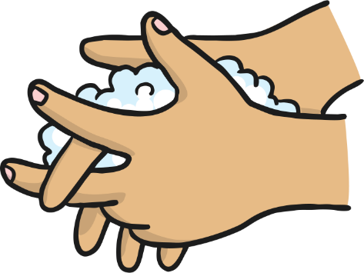
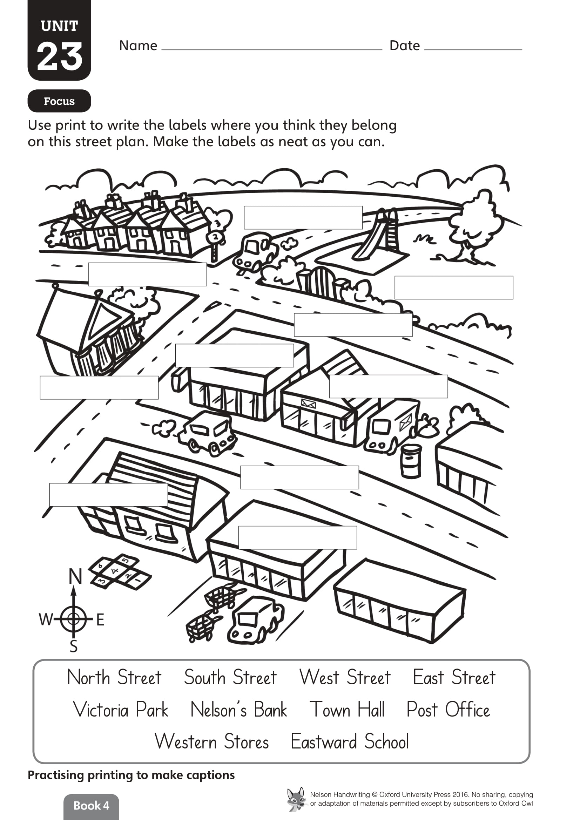
Remember to wash your hands throughout the day!
Monday
Year 6 - Handwriting
Cast your mind back to the beginning of the year.
Were you ready for Year 6?

What surprised you? What did you have to adapt to?
How did the routines change? Did the expectations of your teachers change? If so, how?

Write a list of all the changes, routines and type of work from Year 6 that you can remember. You will be using this list later.

Think about: How lessons are run, what your responsibilities are, what was challenging?

Non-fiction writing
Monday
Year 6 - English

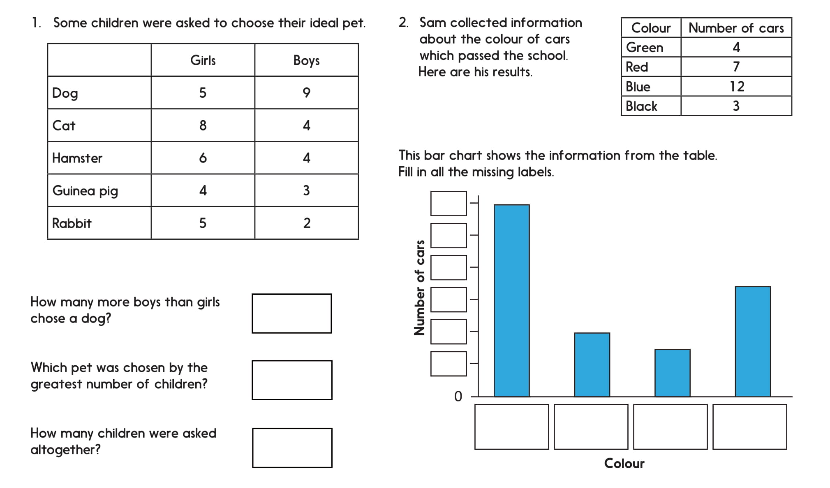
Interpreting graphs
Monday
Year 6 - Maths

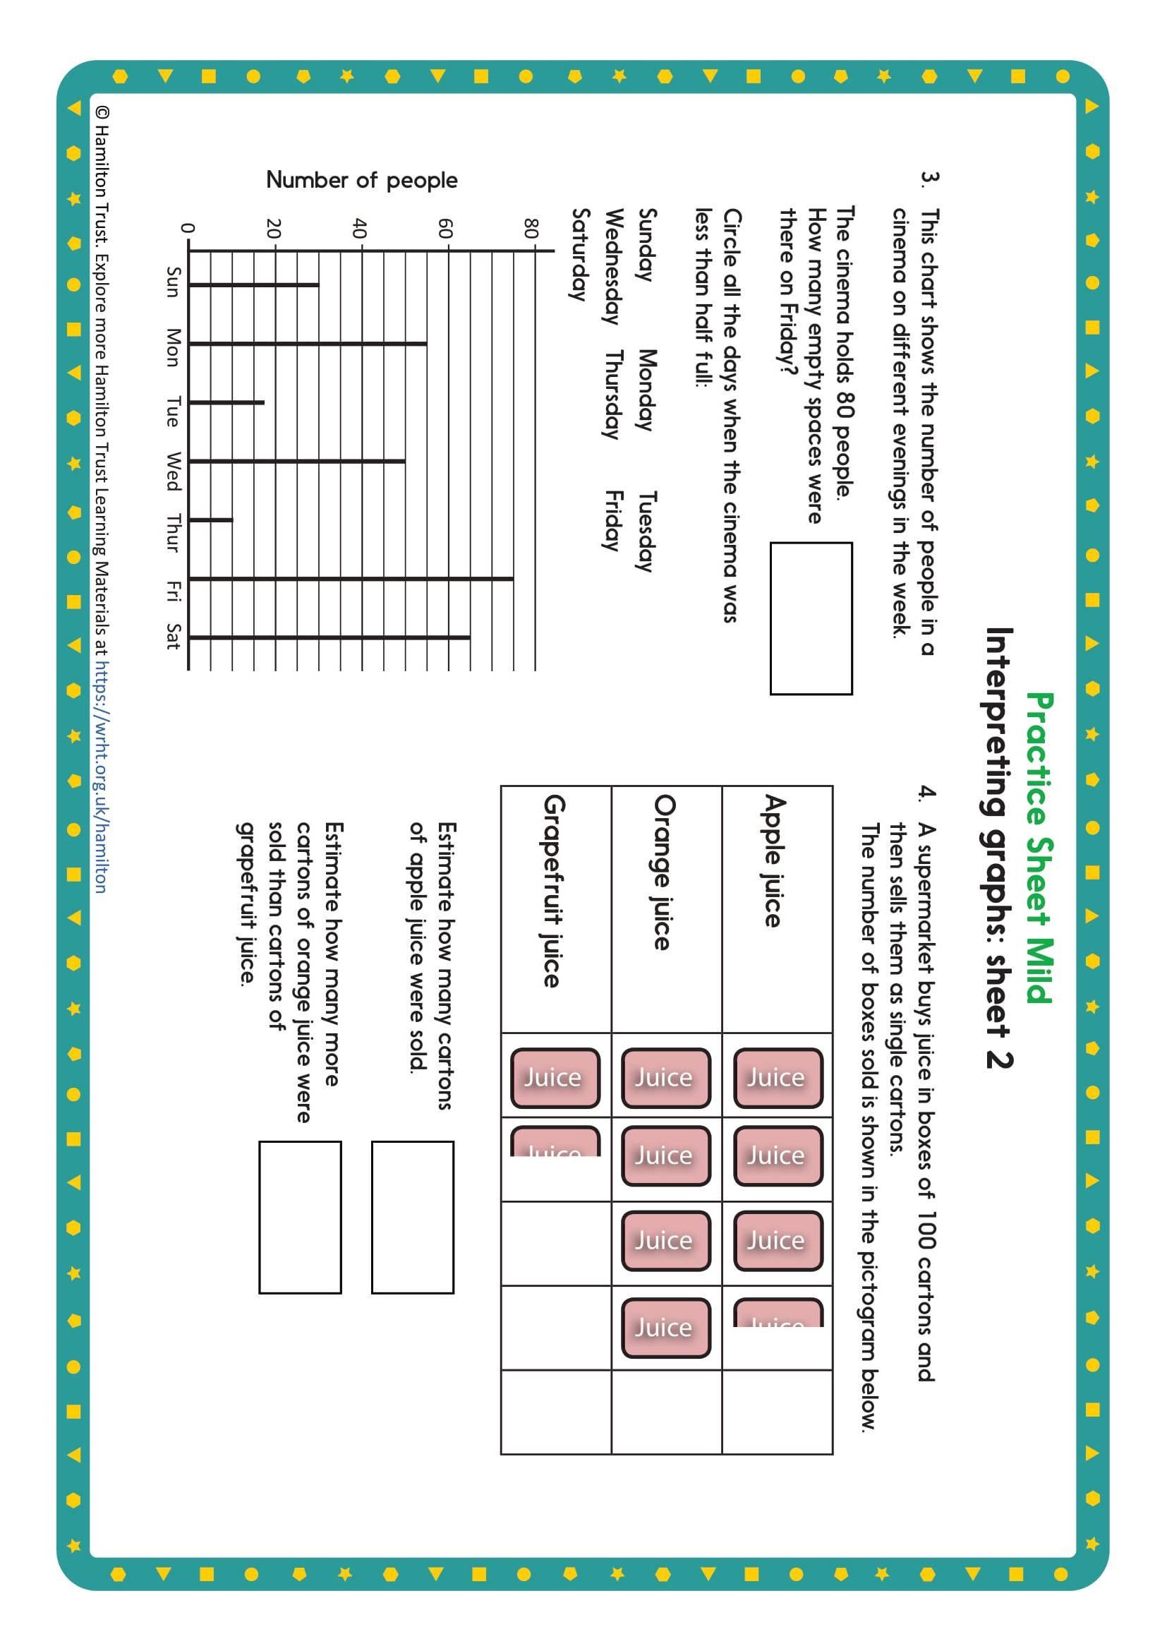

Problem solving

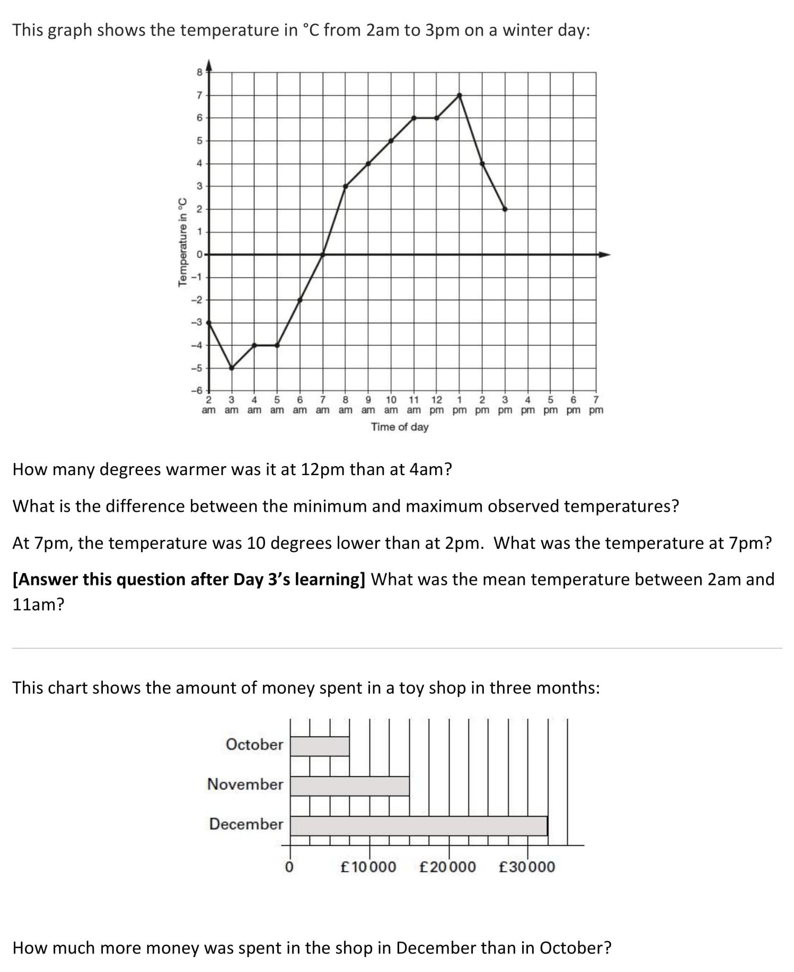
History of Alchemy
Monday
Year 6 - Reading

Alchemy is an ancient area of study. Alchemists attempted to purify and change certain materials. It is believed to have begun in Egypt and was developed in Ancient Greece.
It was introduced to western Europe in the eighth century when Arab settlers brought it to Spain. From here it quickly spread to the rest of Europe.
Alchemists believed that all metals were made up of a mix of mercury and sulphur. Gold was seen as the perfect metal and all other metals were seen as less perfect. Some alchemists believed that other metals could be changed into gold by using a substance that they called the Philosopher’s Stone. They believed that the stone could make people live for ever. The Chinese name for the stone was the ‘Pill of Immortality’.
The study of alchemy continued for hundreds of years. By the sixteenth century there were two groups of alchemists.
The first group focussed on the discovery of new materials and their reactions. Their work led to what is now the science of chemistry.
The second group continued to look at the more mysterious and strange side of alchemy. They searched for immortality and the change (transmutation) of lower metals into pure gold.
Famous alchemists include: Geber, Albertus Magnus and Isaac Newton.

Alchemy Questions
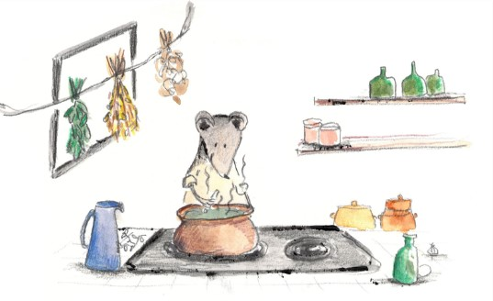
- Where is alchemy believed to have begun?
- What did alchemists believe about all metals?
- What did alchemists believe about gold?
- What did alchemists believe about the ‘Philosopher’s Stone’?
- What word means living for ever/never dying?
- Which of the sciences did alchemy develop into?
- What word do alchemists use for changing lower metals into pure gold?

Tuesday
Year 6 - Handwriting

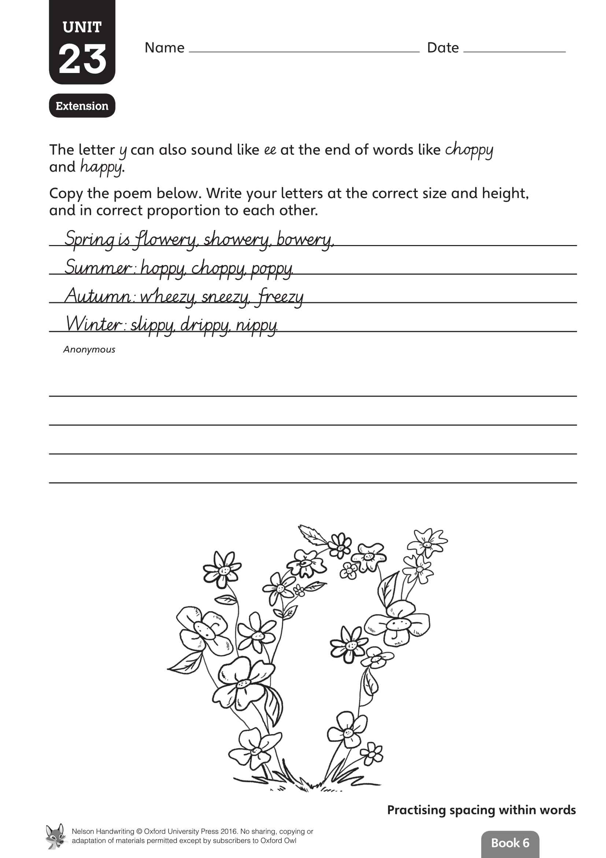
Tuesday
Year 6 - English
Non-fiction writing
Writing a handbook.

A handbook is a guide that contains instructions or advice about how to do something or the most important and useful information about a subject.
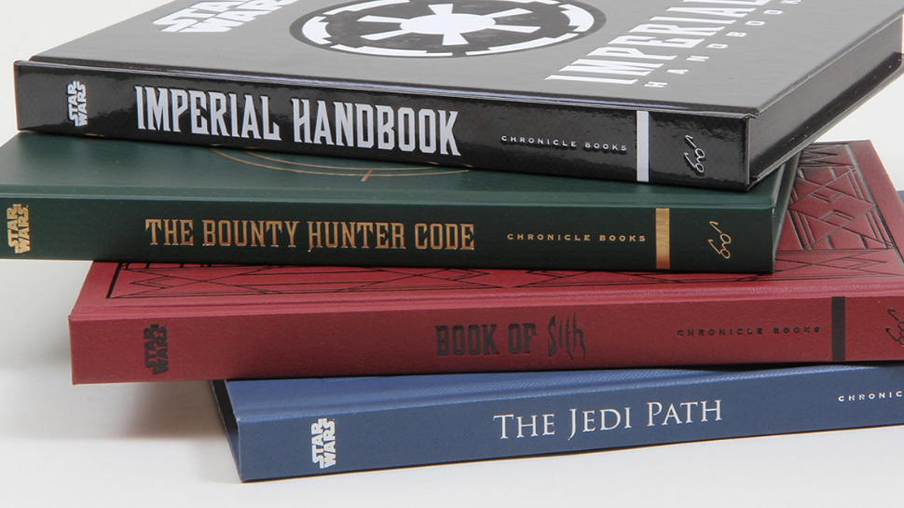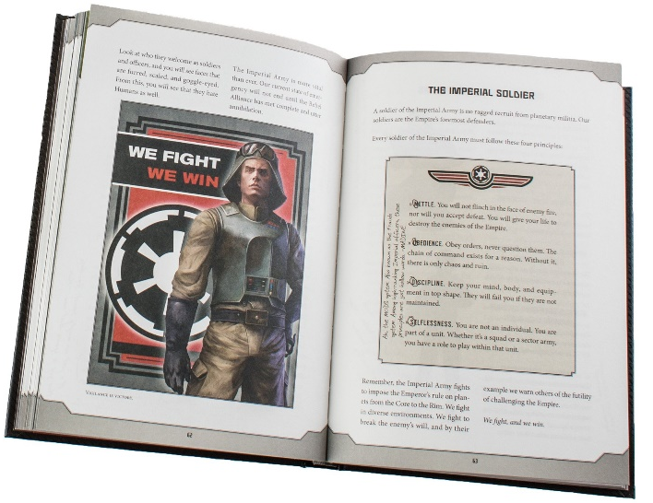
It could be about anything. Here are some handbooks about how to survive in the Star Wars universe. They explain what things mean, qualities you need, what you will be expected to do and how.

Using the list you wrote in the previous lesson, start planning out a Year 6 Handbook for Year 5 to help them prepare and cope next year. Organise your advice into goups that you can present to a reader. You can do this using a spider diagram or brainstorm.
Here’s an example:
Times
tables
SPAG
Maths
Handwriting
English
Lessons
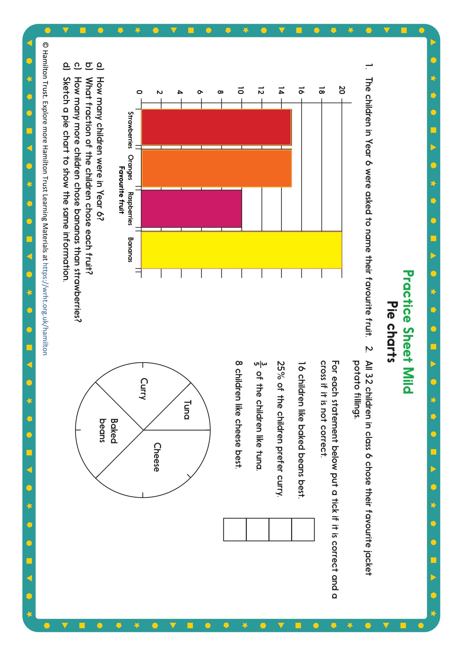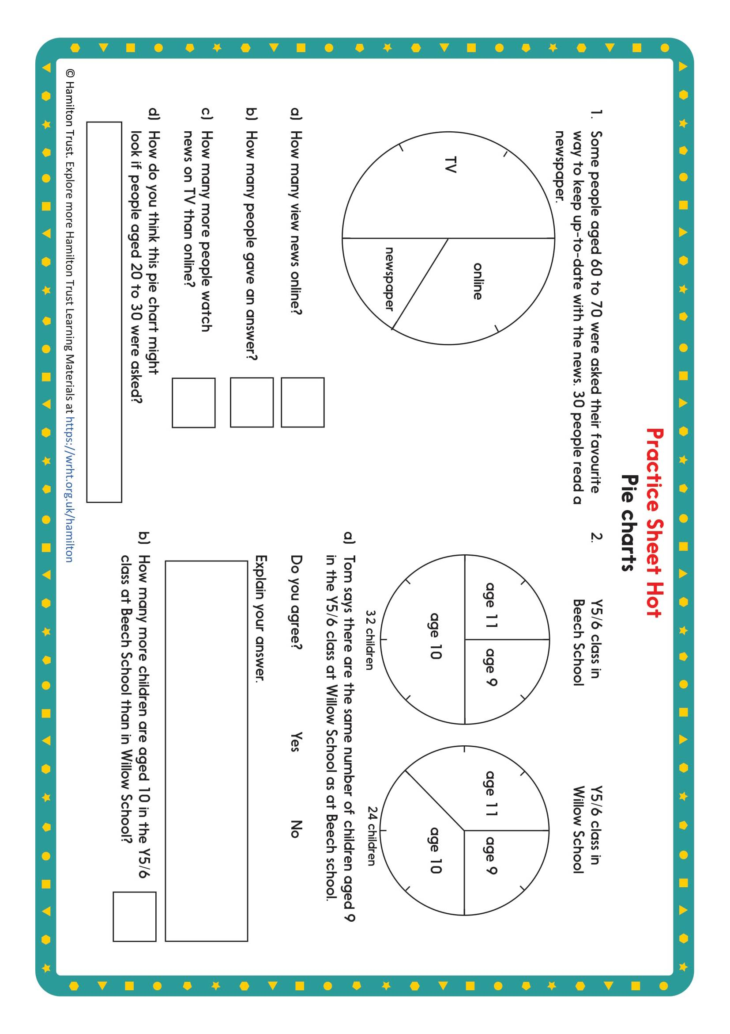
Pie Charts
Tuesday
Year 6 - Maths
Pie Charts: Challenge

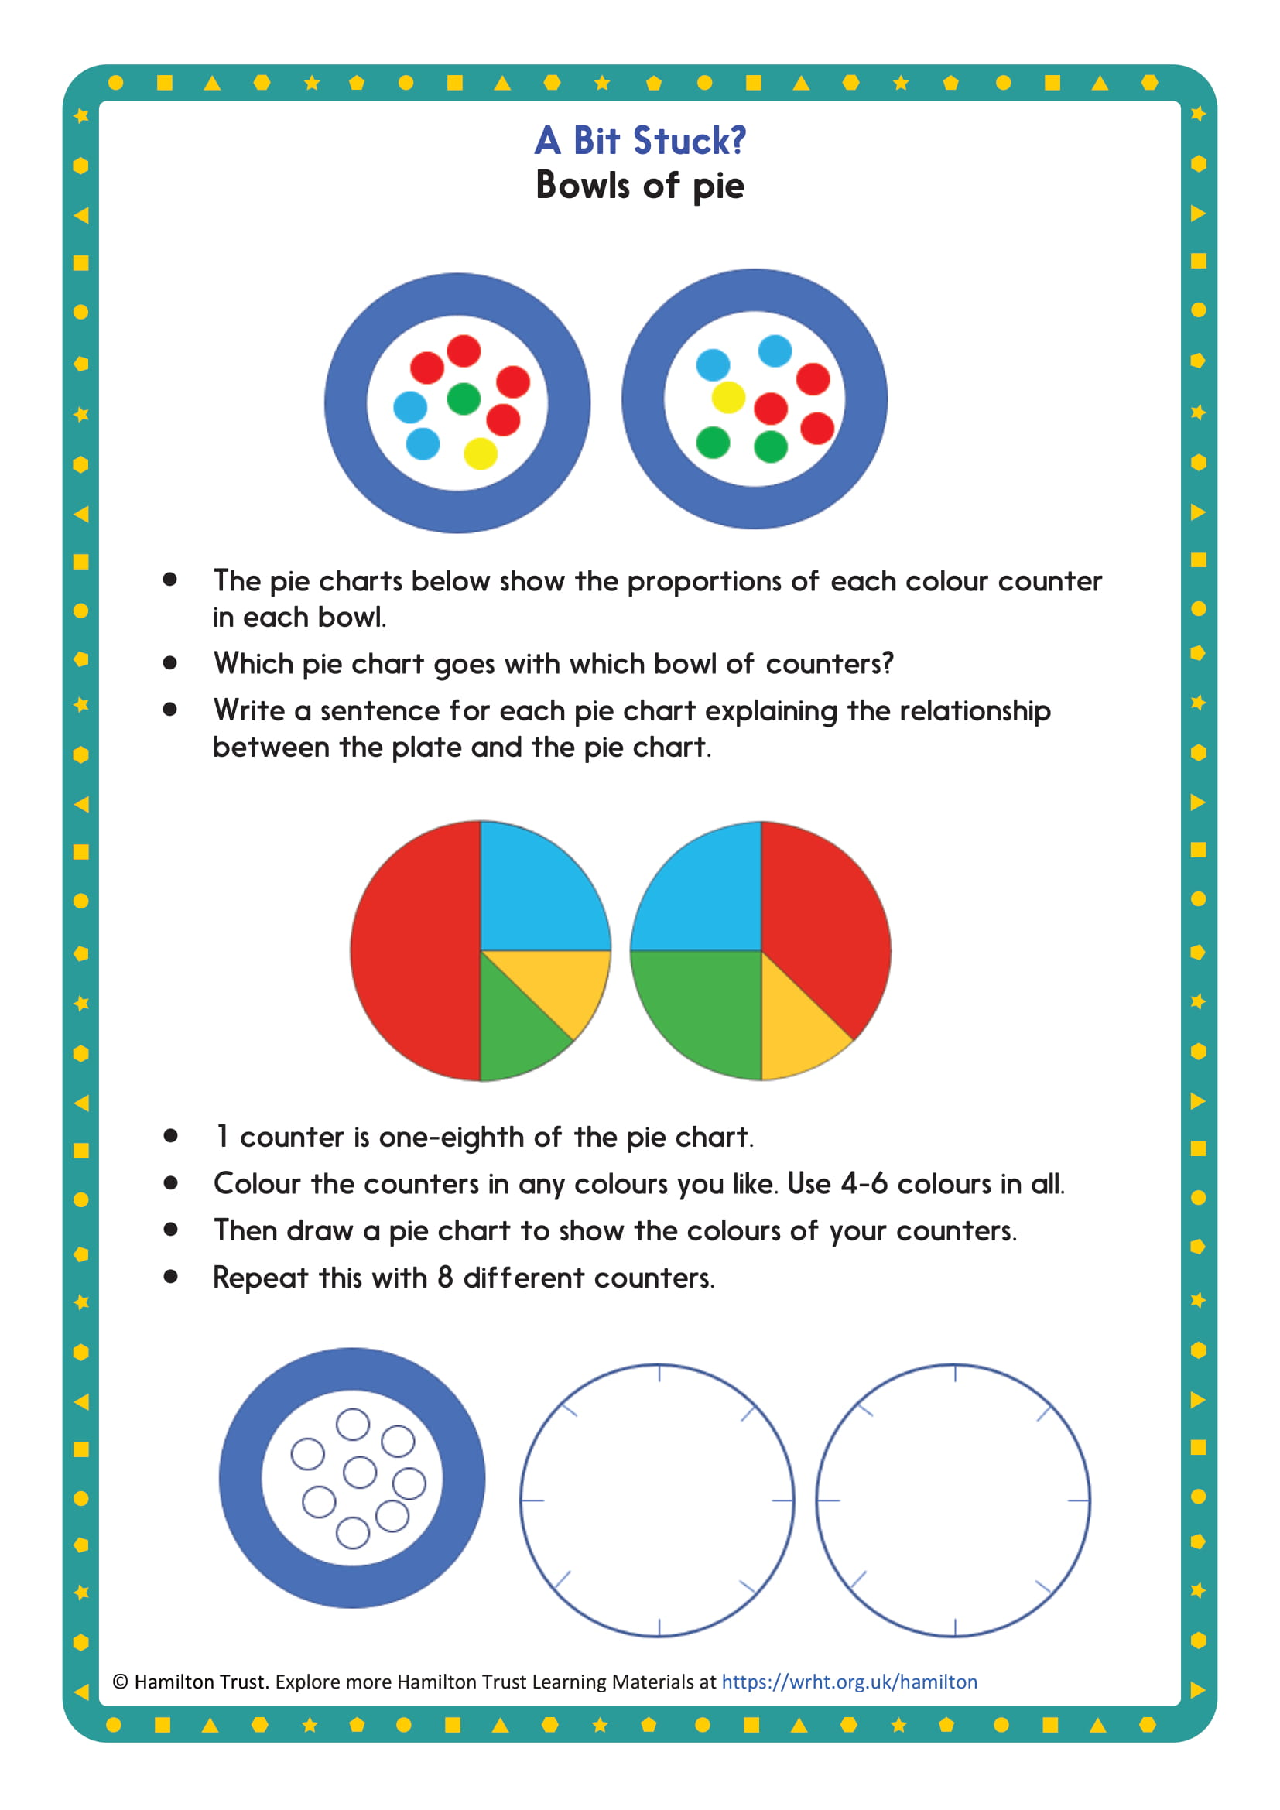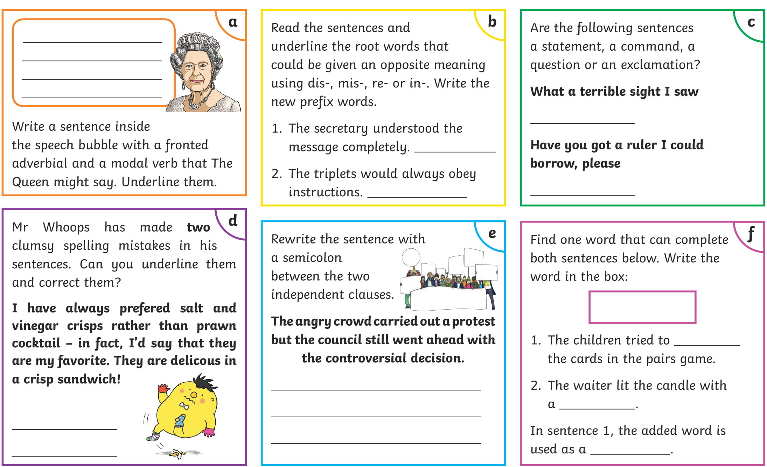
Wednesday
Year 6 - SPAG
Spag

Non-Fiction writing Year 6 Handbook
Wednesday
Year 6 - English
Start writing your handbook

Use your ideas from the last session to help you write. Think about your audience, what do you think they need to know about each subject? Have you used any tricky words? Make sure you have a glossary of words or explain them in the text.

Think about:
Headings and subheadings - How will you group your information together?
Making information easy to find - Non-fiction books can be read out of order and the reader may need a piece of information immediately. Make sure it’s not longer than it needs to be and your information is clear!

Here is an example:
Maths

A subject that some children find challenging but is incredibly important. You will be doings some sort of maths each day. It involves lots of different skills including, mental recall, drawing accurately, measuring, shape recognition and much more.

Arithmetic
Prime numbers - numbers that can only be divided by themselves and one
Factors - …etc
Things you will be expected to know off by heart:
- All your times tables facts up to 12 x 12
- Number bonds to 100 using mental strategies
- Factors, multiples and prime numbers

Wednesday
Year 6 - Maths
Pie chart starter

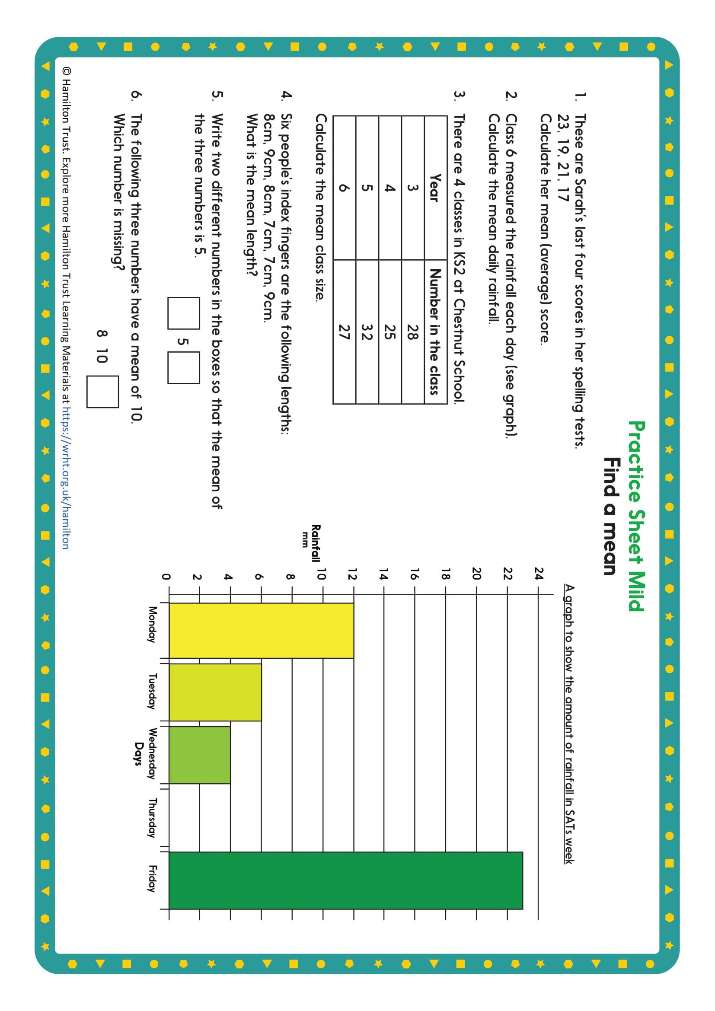
Wednesday
Year 6 - Maths
Finding the mean
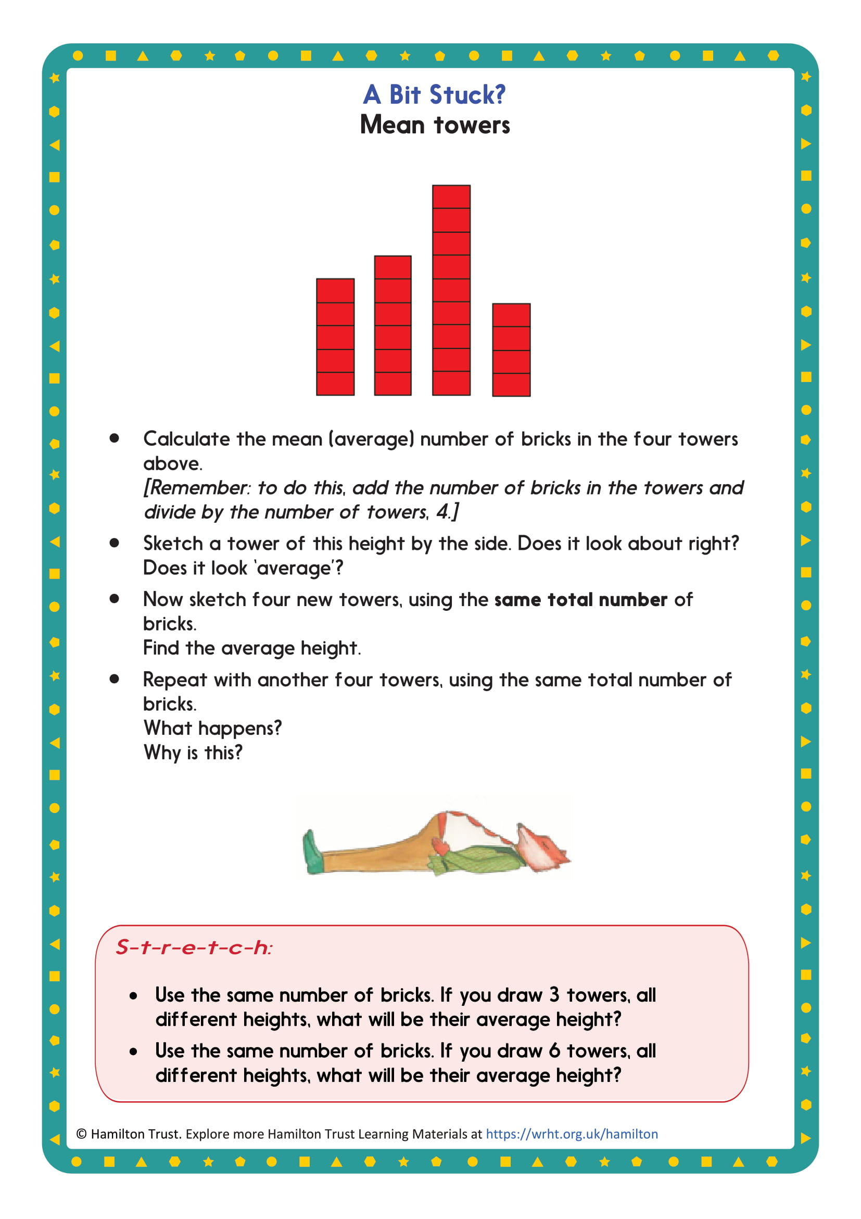
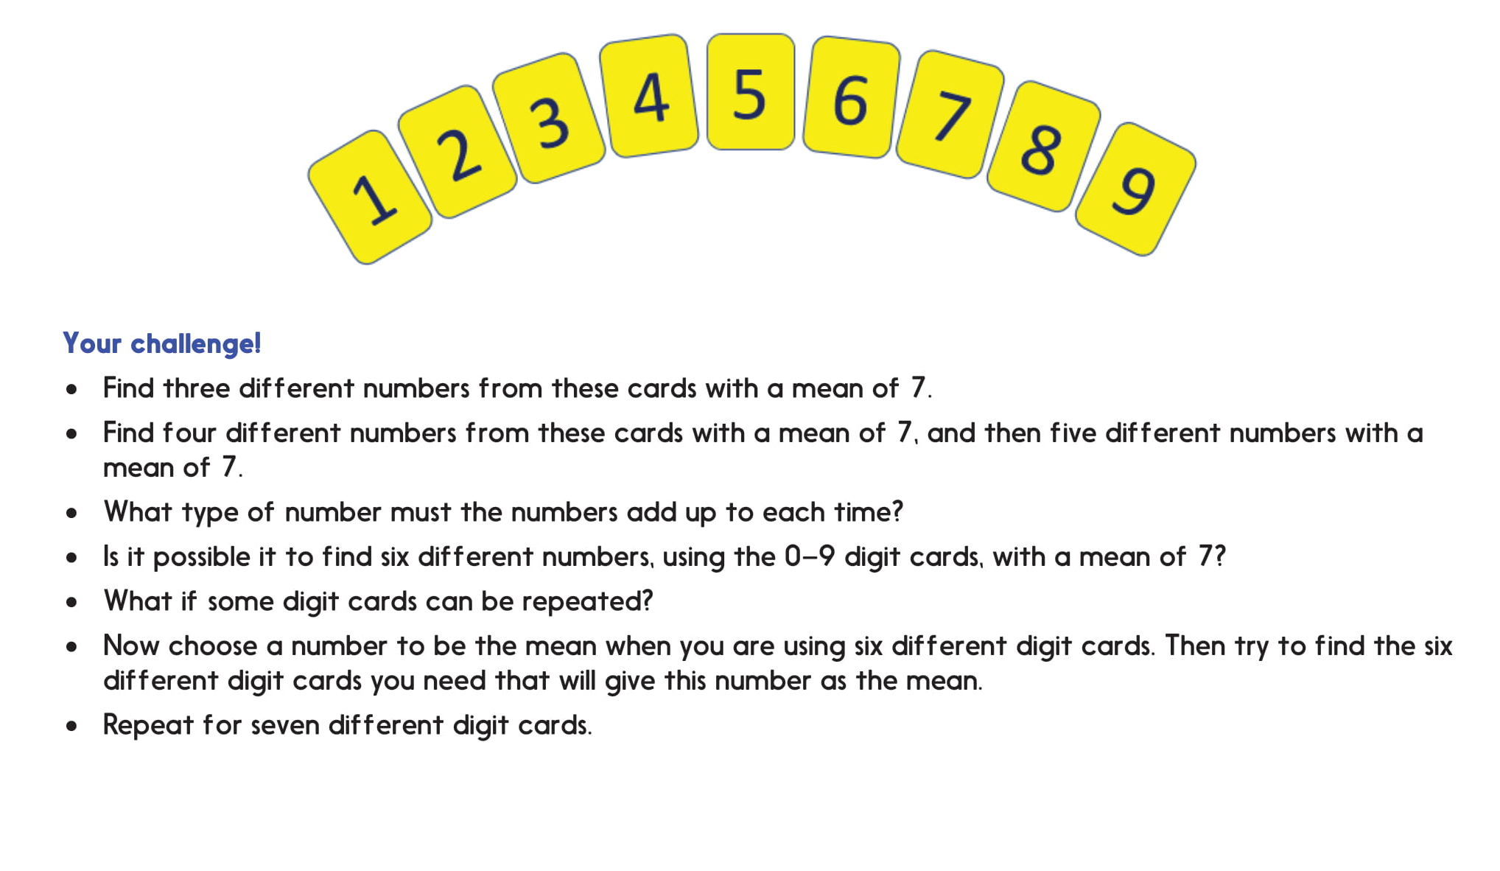
Finding the mean
Wednesday
Year 6 - Maths
King Midas and the Golden Touch
Wednesday
Year 6 - Reading

Once upon a time, a long time ago in ancient Greece, there lived a king named Midas. King Midas loved three things more than anything else in the world - his little daughter, his rose garden, and gold. Nothing gave him more pleasure than seeing his little daughter picking roses in the garden, roses she placed in a golden vase to decorate the castle.

One night, while strolling through his rose garden, the king stumbled over a satyr. A satyr was half man, half goat. This satyr looked half-starved and very ill. King Midas brought the satyr into his castle. He made sure the satyr was washed and fed and tucked into bed for a good night's sleep. When the satyr woke up the next morning, his fever was gone. The king and the satyr had quite a nice chat over breakfast. King Midas was surprised to hear that the satyr belonged to the powerful god Dionysus, the god of wine and truth. That very day, the king personally took the satyr home in his very best chariot.

Dionysus told the king he would grant any one wish the king made to thank him for taking such good care of his friend. The king did not wish anything for his daughter because he had given her everything she wanted and a whole lot more besides. He did not wish anything for his rose garden because everyone knew he grew the finest roses in all the world. That left gold. King Midas wished that everything he touched would turn to gold.

When the king arrived back at his castle, he pulled out a chair to sit down at his table. The minute he touched it, the chair turned to gold. He touched the table. He touched a vase. As soon as he touched them, they turned to gold. King Midas raced through his castle. Everything he touched turned to gold! He was so happy. He shouted to his servants to cook him a feast in celebration!

His servants served him a feast. That's when the trouble started. Everything looked and smelled so good that King Midas did not wait for his daughter to show up for lunch. He reached out and grabbed a fistful of food. The food made quite a clatter when he dropped it back on the table in shock. It had turned to gold in his fist. He touched other food. Whatever he touched turned to gold. He tried leaning over and ripping a piece of meat with his teeth, but that did not help. The meat turned to gold in his mouth. The king's eyes filled with fear. | 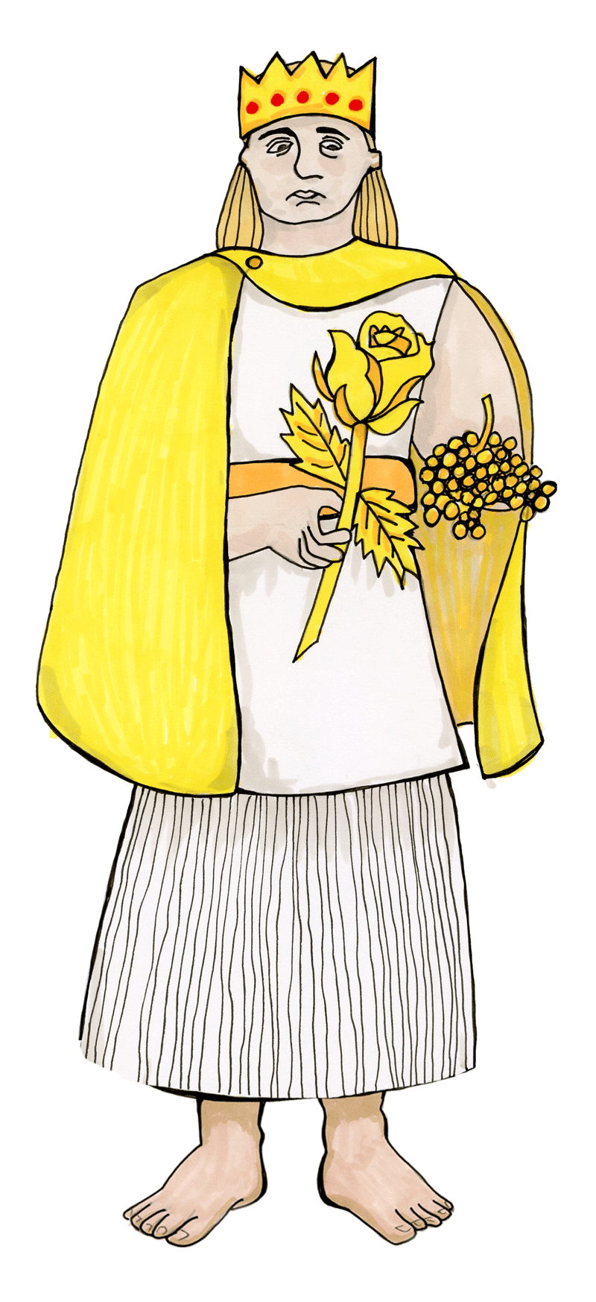
He knew if he could not eat, he would starve. This was terrible. The king did not know what to do.

King Midas wandered sadly out to his rose garden. His little daughter was in the garden, picking roses. When she saw her father, she ran into his arms for a hug and turned to gold. King Midas hung his head and cried. As his tears fell on his precious roses they turned to gold, but the king did not care. He did not care about his roses or his gold or himself. Dionysus, hear my prayer, the king begged. Take my wish back! Please, take my wish back and save my daughter!

One last time, the king's wish was granted.

Comparison Table

How are the stories of King Midas and The Last Alchemist similar and how are they different?

Explain your answers

Similarities | Differences

Finish off your handbook. Once you’ve finished, check your work for these things:
Non-fiction writing
Editing
Thursday
Year 6 - English

Presentation – Is your work neat and easy to read?
Punctuation – including your headings and subheadings: They need capitals!
Spelling – Get a dictionary if you’re not sure!
Grammar – Does each sentence make sense? Have you used formal English? Is it all in the right tense?
Quality – Have you repeated any information? Have you used a phrase or word too many times?

Read it to yourself, out loud if you can, it’s the best way of checking!

Properties
Thursday
Year 6 - Maths

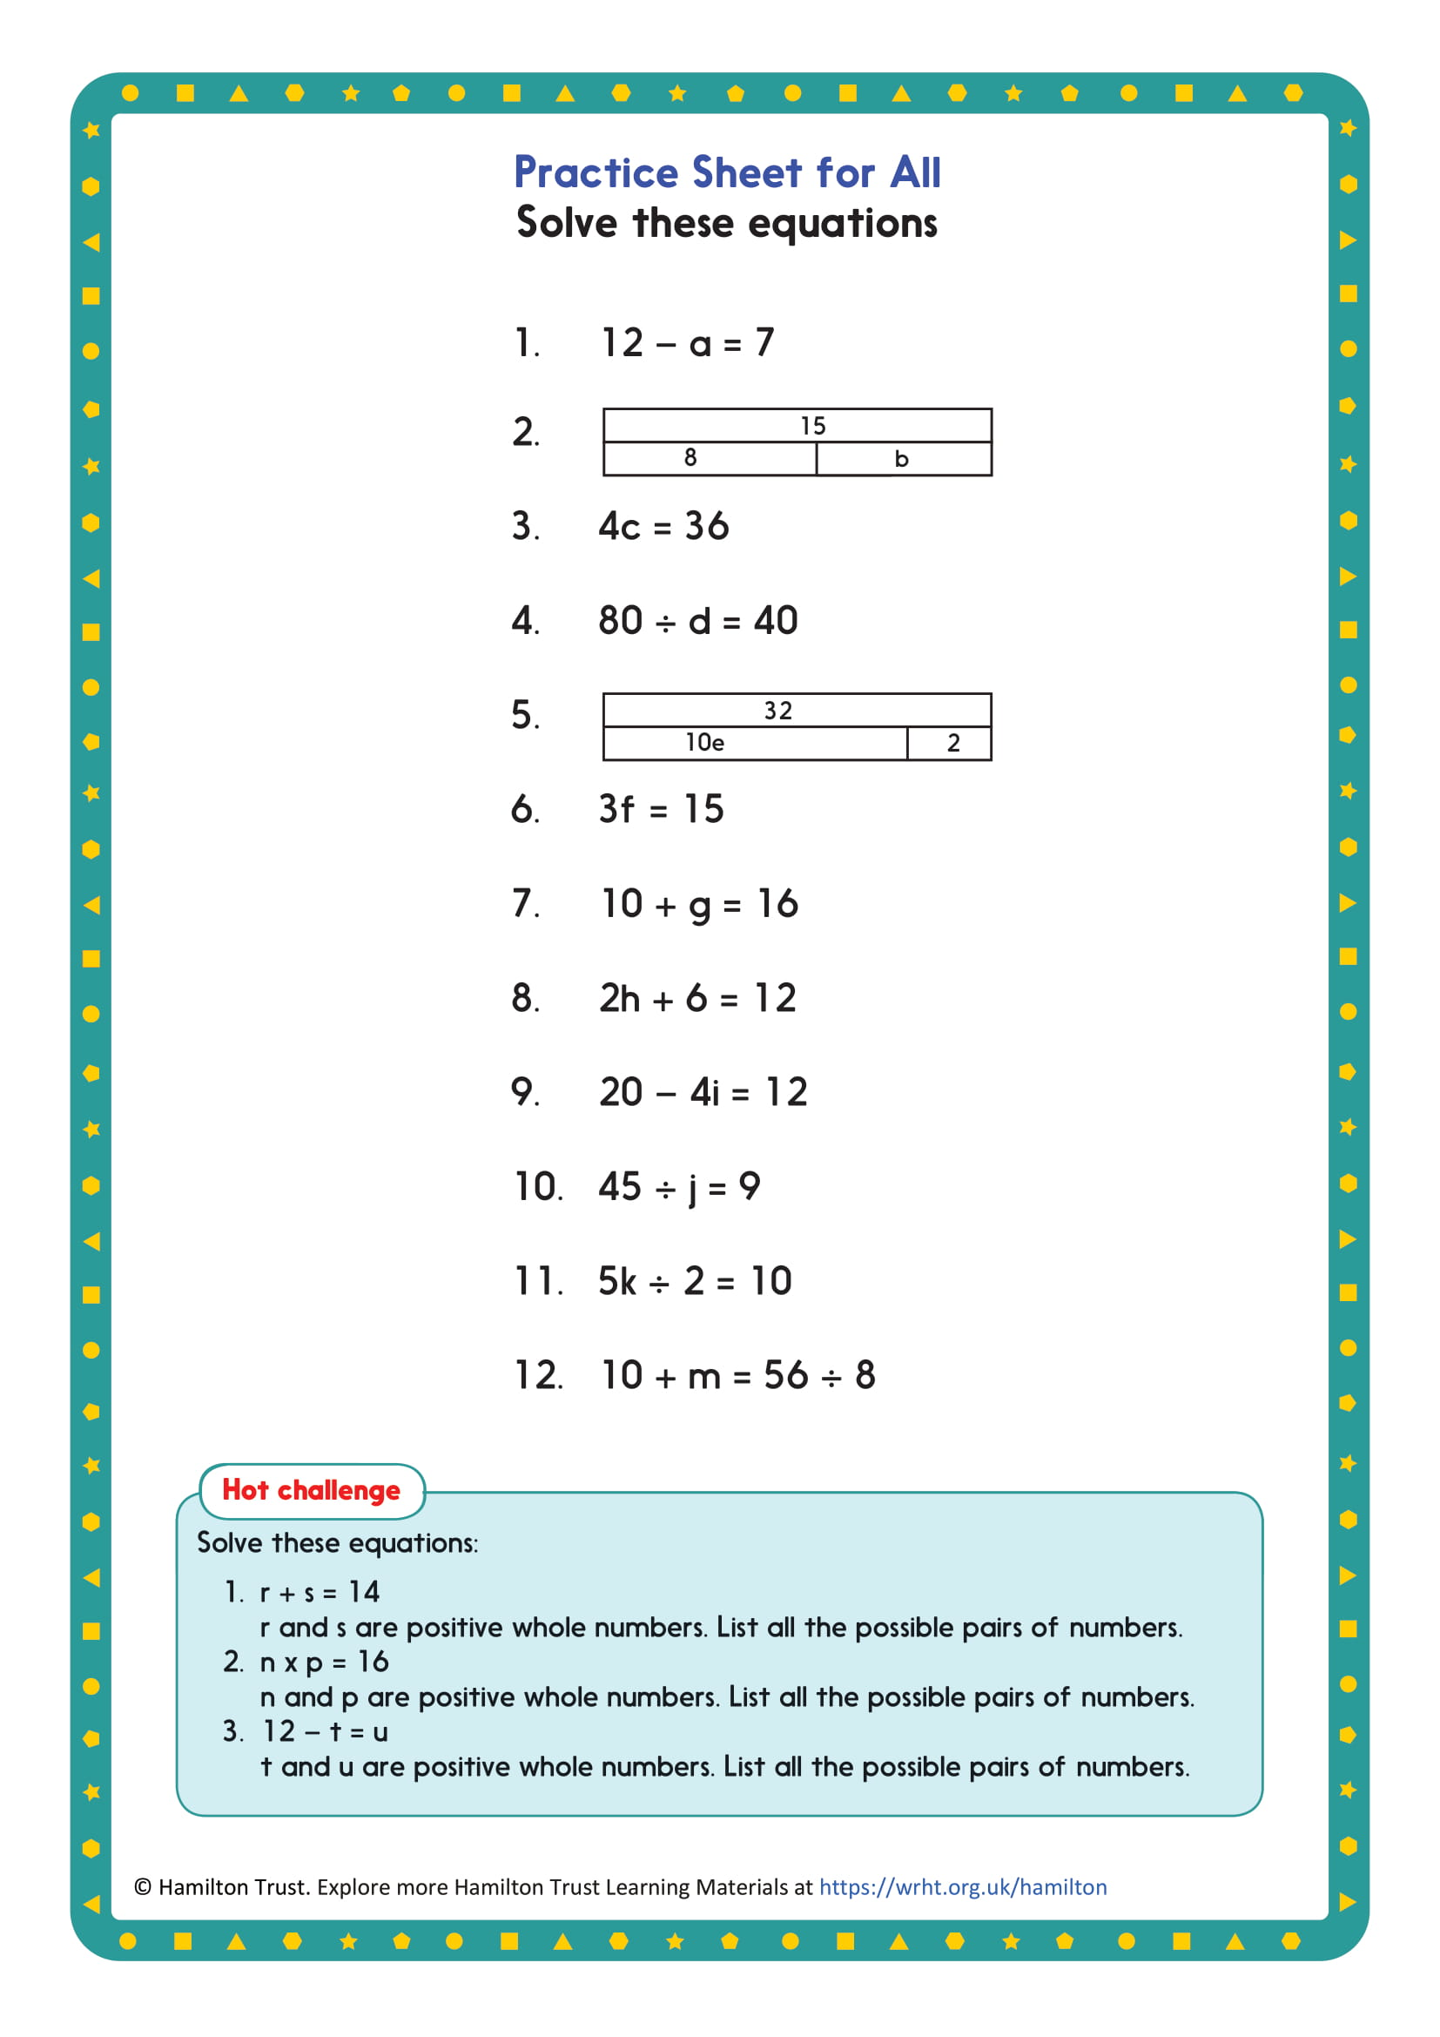
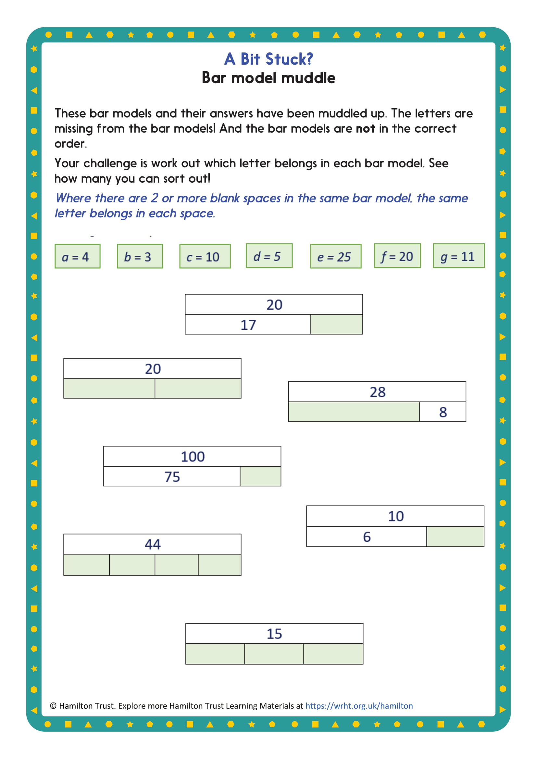

Problem solving
Thursday
Year 6 - Maths

Proverbs
Friday
Year 6 - English
A proverb is an old fashioned saying that has a meaning that is usually (but not always) good advice.
What do you think these proverbs mean?

Match them up!

Proverb | Meaning
A leopard can’t change  its spots. | Achieve two things with one action.
Kill two birds with one stone. | Sometimes it is better for one person to do a job, rather than lots of people.
Too many cooks spoil  the broth. | Something that can be both a good thing and a bad thing at the same time.
Out of sight, out of mind. | If you can’t see someone or something, you soon forget about them.
A double-edged sword. | Two people can get on better when there’s no one else.
A person is known by the  company he keeps. | Something that’s dangerous, but looks innocent.
A wolf in sheep’s clothing. | People tend to join people that like the same things.
Birds of a feather  flock together. | If you want to know about someone look at his friends.
Two’s company, three’s  a crowd. | Some people never change.

Match the proverbs with the meanings:

- Don’t cross your bridges before you come to them
- You scratch my back and I’ll scratch yours
- There’s no time like the present
- Many hands make light work
- What the eye doesn’t see the heart doesn’t grieve over
- A miss is as good as a mile
- You can’t teach an old dog new tricks
- Spare the rod and spoil the child
- Flattery will get you nowhere
- You can’t have your cake and eat it
- A leopard can’t change its spots
- Necessity is the mother of invention

Match the proverbs with the meanings:

a) It’s best to get on with things at once.
b) People never change their basic character.
c) If you help me, I’ll help you.
d) You will have to choose between two good things – you can’t have them both.
e) If something is really needed, someone will invent it.
f) You won’t get anywhere by paying people empty compliments.
g) If you don’t discipline a child, it will end up spoilt.
h) Don’t start worrying about obstacles that you haven’t come across yet.
i) It is easier to complete a task when everyone helps.
j) What you don’t know about, won’t worry or upset you.
k) When you fail by a small margin, it has the same effect as failing by a larger margin.
l) When someone is set in their ways, it is hard for them to learn new ways of doing things.

Friday
Year 6 - Maths
Sequences

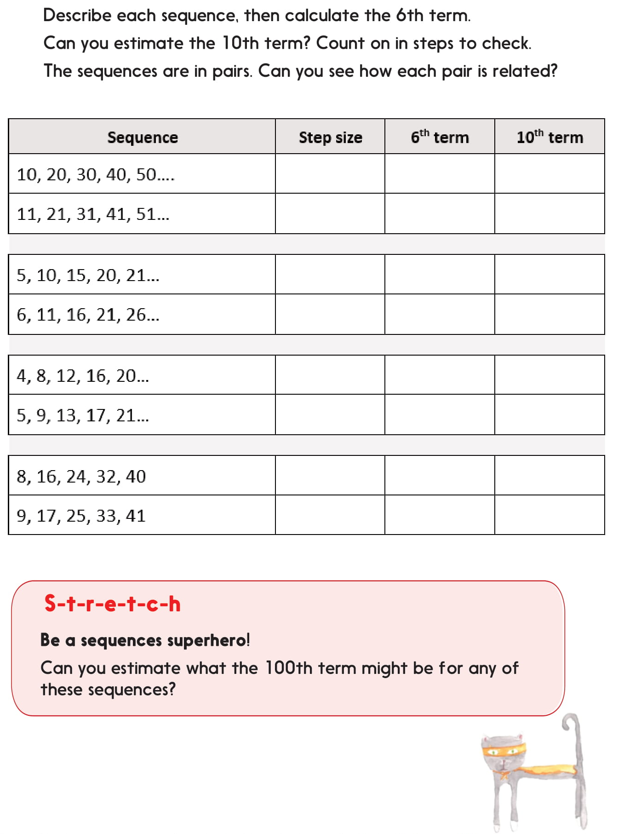
Challenge:
Problem solving

You choose!
Afternoon
Year 6 - Choosing

Choose an activity, in any order you like.
You can create your own version of any task or activity, including questions for your classmates, friends or family.

Other ideas include:

Write a journal for your day or week.

Write a book report. Remember your audience. Would you recommend the book? Why? To whom?

Make a list. Lots of You Tube videos are lists of things. What would your top ten video be about? Can you write a script for it?

Make a quiz. It could be any kind, maths, history, films, videogames, emoji. You decide.

Create a puzzle.

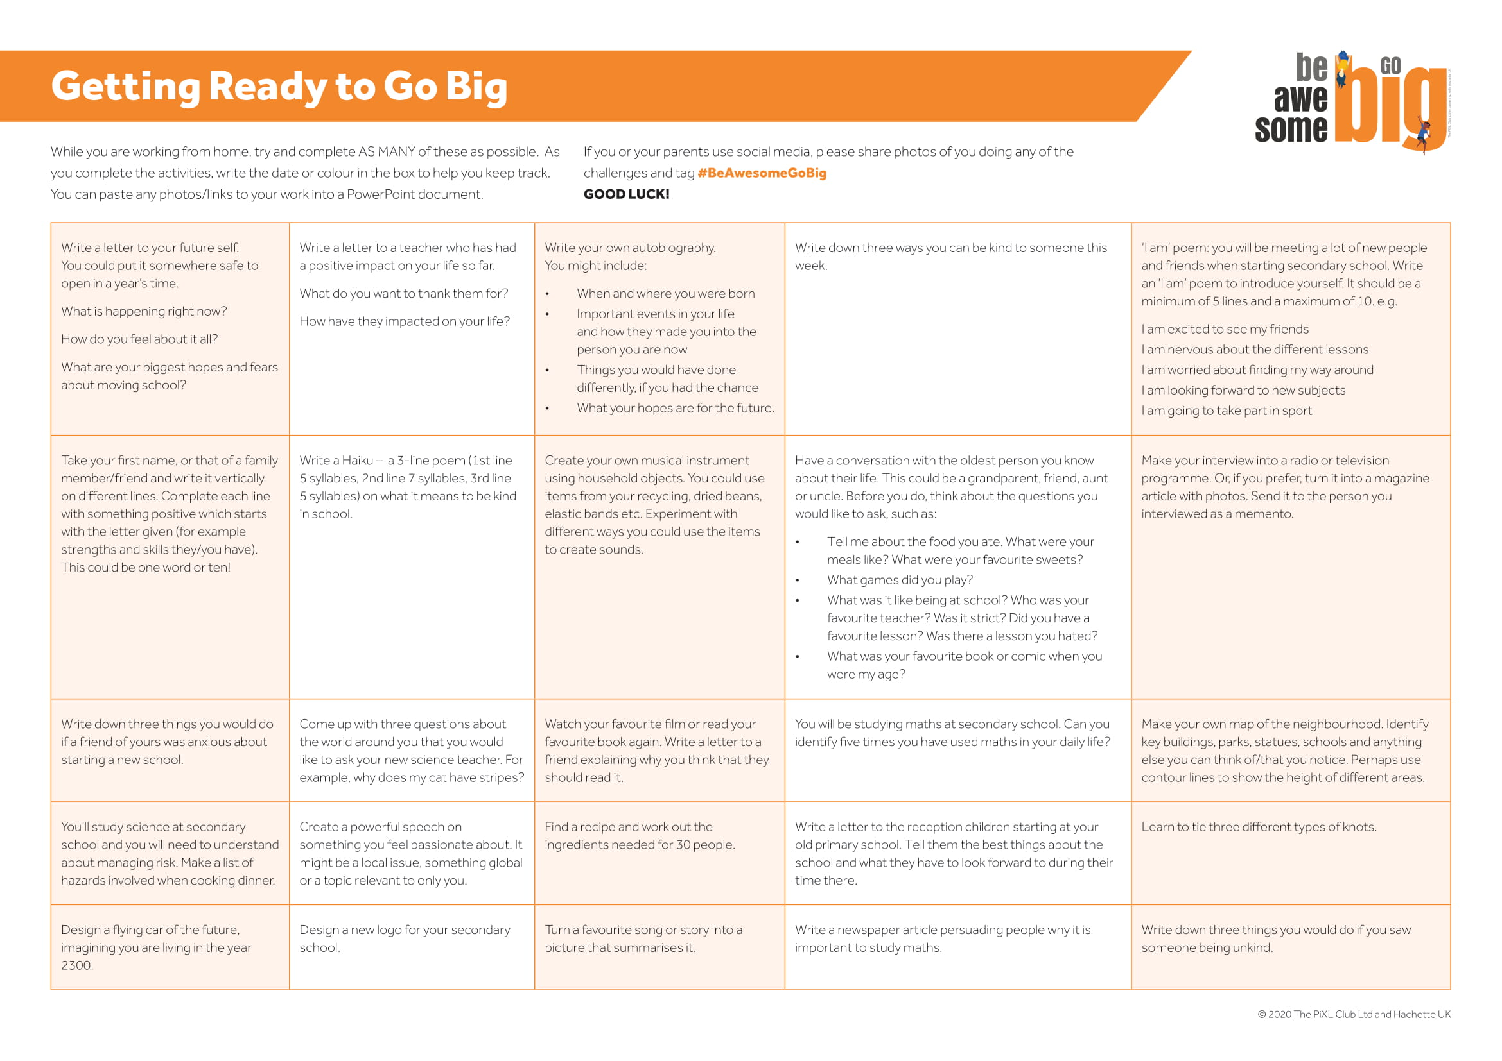
Afternoon
Year 6 - Science

Science
What if…?

Write a positive, negative and interesting way to think about the question. ie. What would be good, bad or interesting about penguins flying?
Stuck for ideas? Think about:
- Would penguins look different if they were able to fly?
- If penguins could fly would there be a greater variety of food available?
- If their wings were bigger would they still be able to swim?
- Would being able to fly help them get away from predators more easily?
- Every year emperor penguins walk 70 miles to get food for their young – would flying make this easier?
- Is it better to be able to dive to great depths (450m) or fly to get food?
Write your ideas down and if you can, share them with someone. Remember there is no wrong or right answer!

Background science

Flightless birds all evolved from their flying ancestors. Being able to fly could make life in the Antarctic much easier for penguins. The gruelling march of the emperor penguins would take a few hours, if flown, rather than many days! Escaping predators, such as leopard seals would be easier.

In nature, adaptations are usually related to survival and reproduction. Scientists believe penguins stopped being able to fly as it is likely there were no predators where they lived long ago. Penguins rely on the oceans for food and have adapted over time to become more aquatic, exchanging wings for flippers. The changes to their wings and increasing body size allowed them to become more efficient for swimming and diving, but reduced their ability to fly. Penguins sacrificed flight for an incredible ability to dive.

Find out more about the emperor penguin by watching this amazing BBC video, https://www.youtube.com/watch?v=MfstYSUscBc

How much do you know about evolution?
What would you like to know?

Children’s Books Emoji Quiz
Can you name the famous books from these emoji?

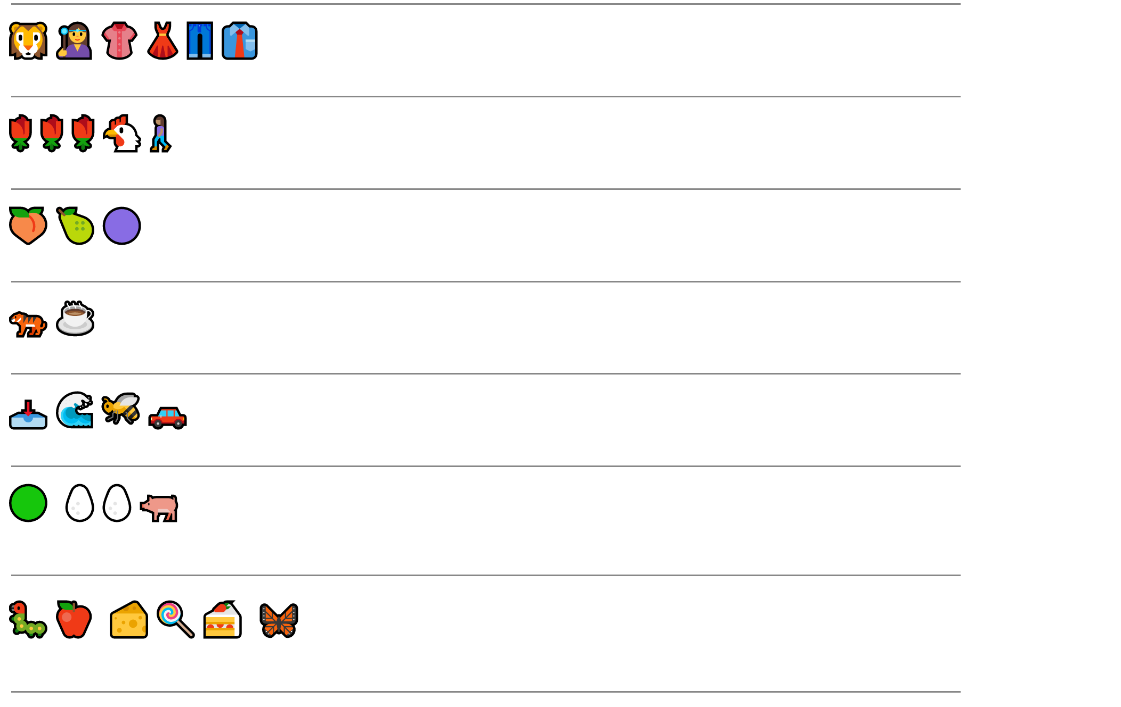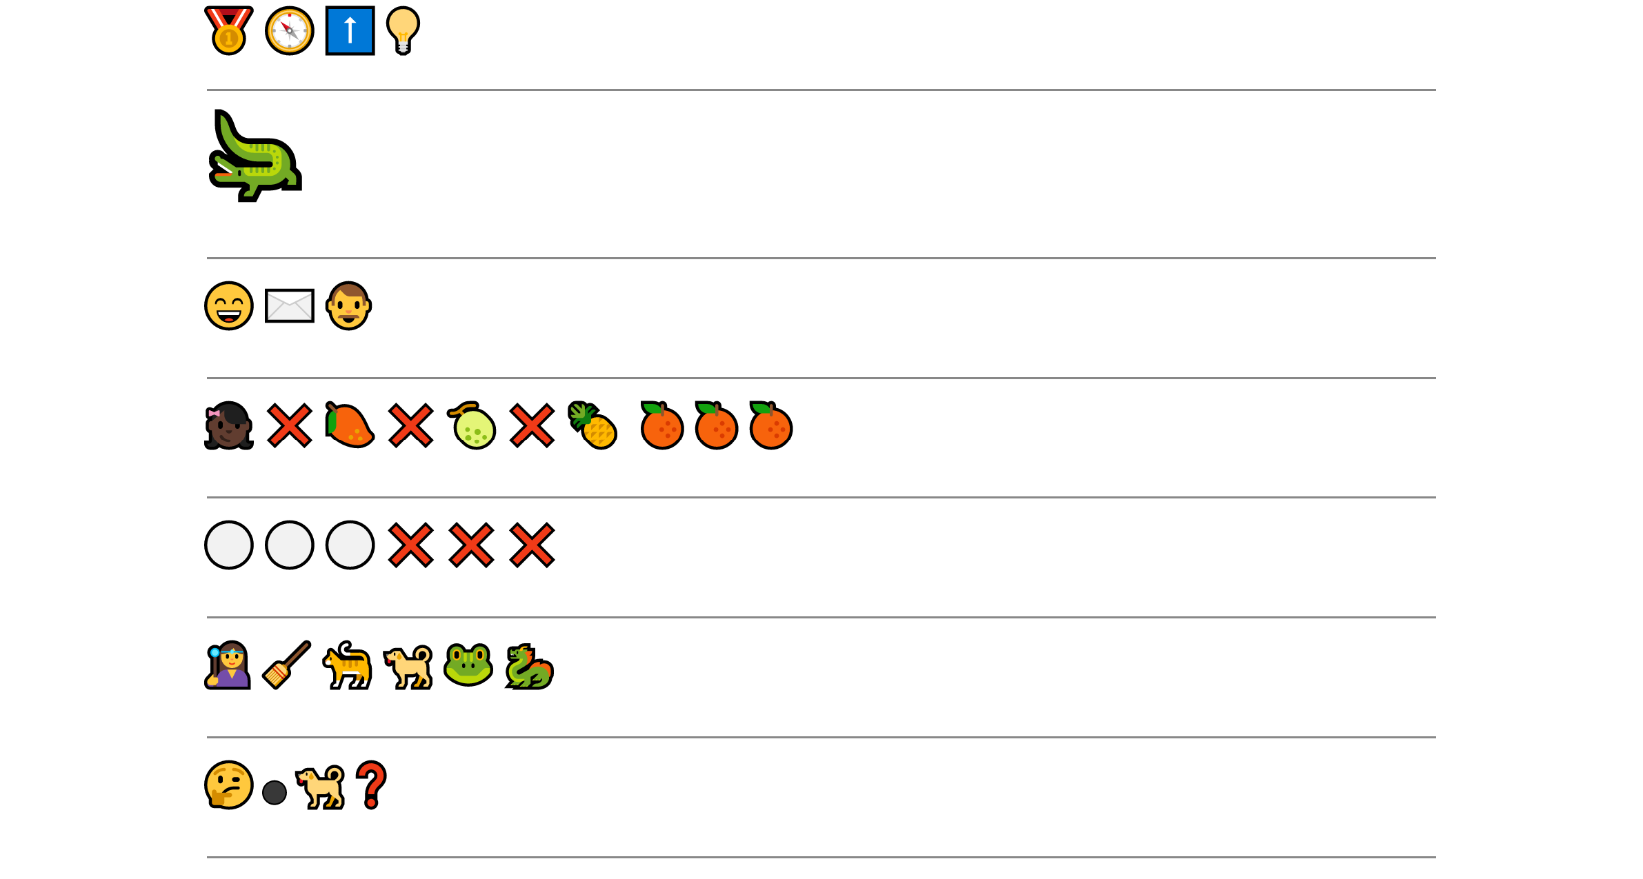
Colouring page!
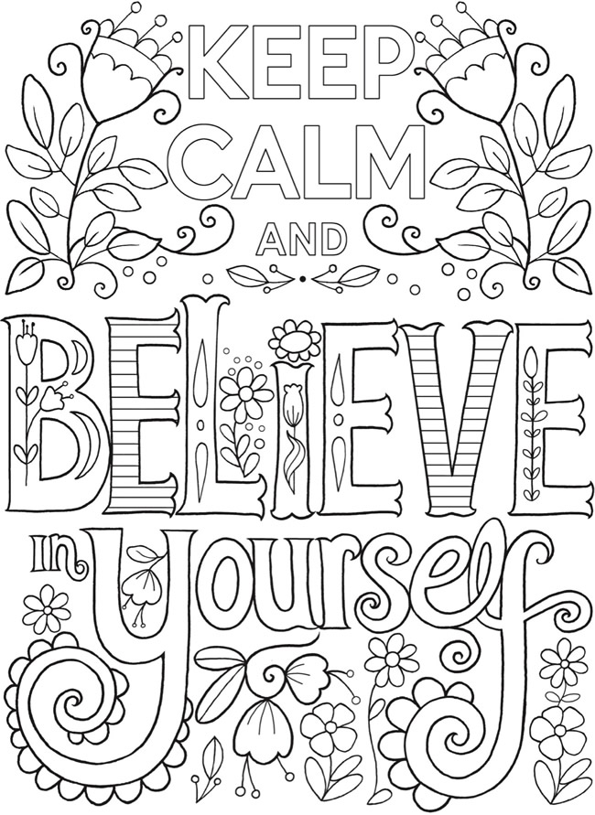
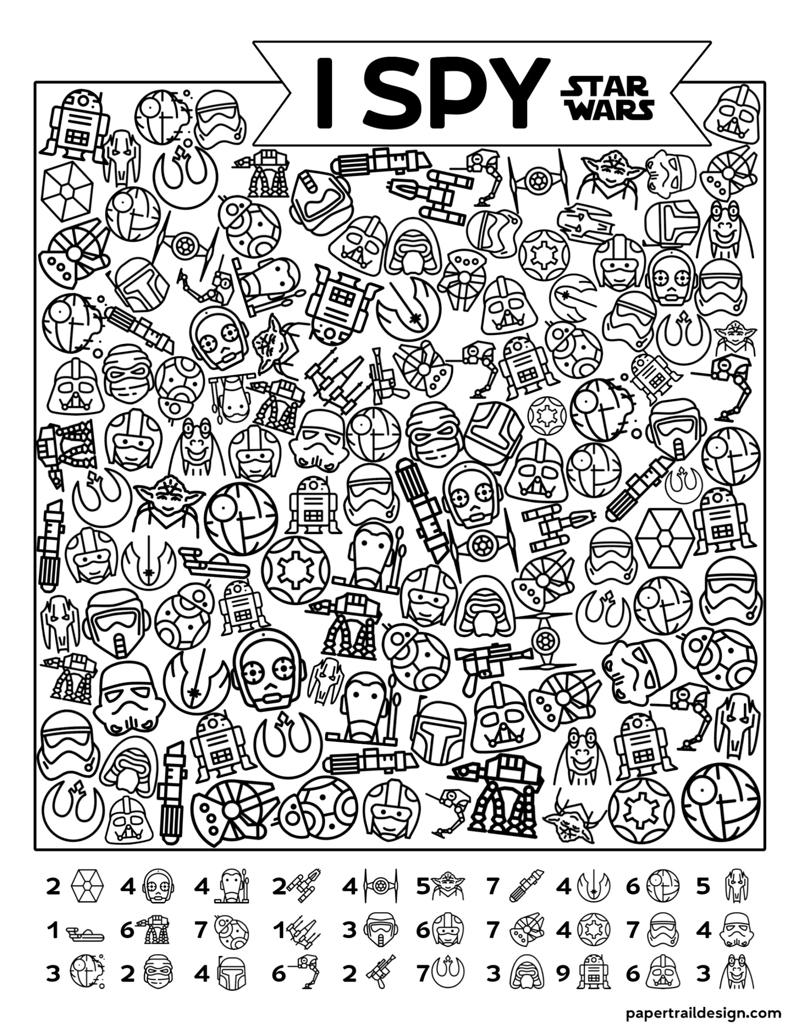
Word ladder puzzles

Each line is a new word. Change ONE letter from a word to make the next word. Use the clues to help you.

K | N | O | W | S
 |  |  |  |  | Happens in winter
 |  |  |  |  | Presents
 |  |  |  |  | You wear these
 |  |  |  |  | Scares away
 |  |  |  |  | Go for goal
 |  |  |  |  | Move quickly
 |  |  |  |  | Pick up ice cream
R | I | C | E
 |  |  |  | Roll them!
 |  |  |  | Rodents
 |  |  |  | 1.61 km
 |  |  |  | Donkey
M | U | L | L

Word ladder puzzles
Change one letter each time to make the next word!

One letter always stays the same in this one.
L | I | N | E
 |  |  |  | Okay
 |  |  |  | A number
 |  |  |  | Swim down
 |  |  |  | Don’t die!
 |  |  |  | Enjoy
 |  |  |  | Body of water
 |  |  |  | Remove
 |  |  |  | Ribbon
 |  |  |  | Cloak
 |  |  |  | Tasty treat
 |  |  |  | Not real
 |  |  |  | Destiny
 |  |  |  | Friend
 |  |  |  | Entrance
 |  |  |  | Play this
 |  |  |  | Strong wind

Afternoon
Year 6 - Spanish
The countries that speak Spanish

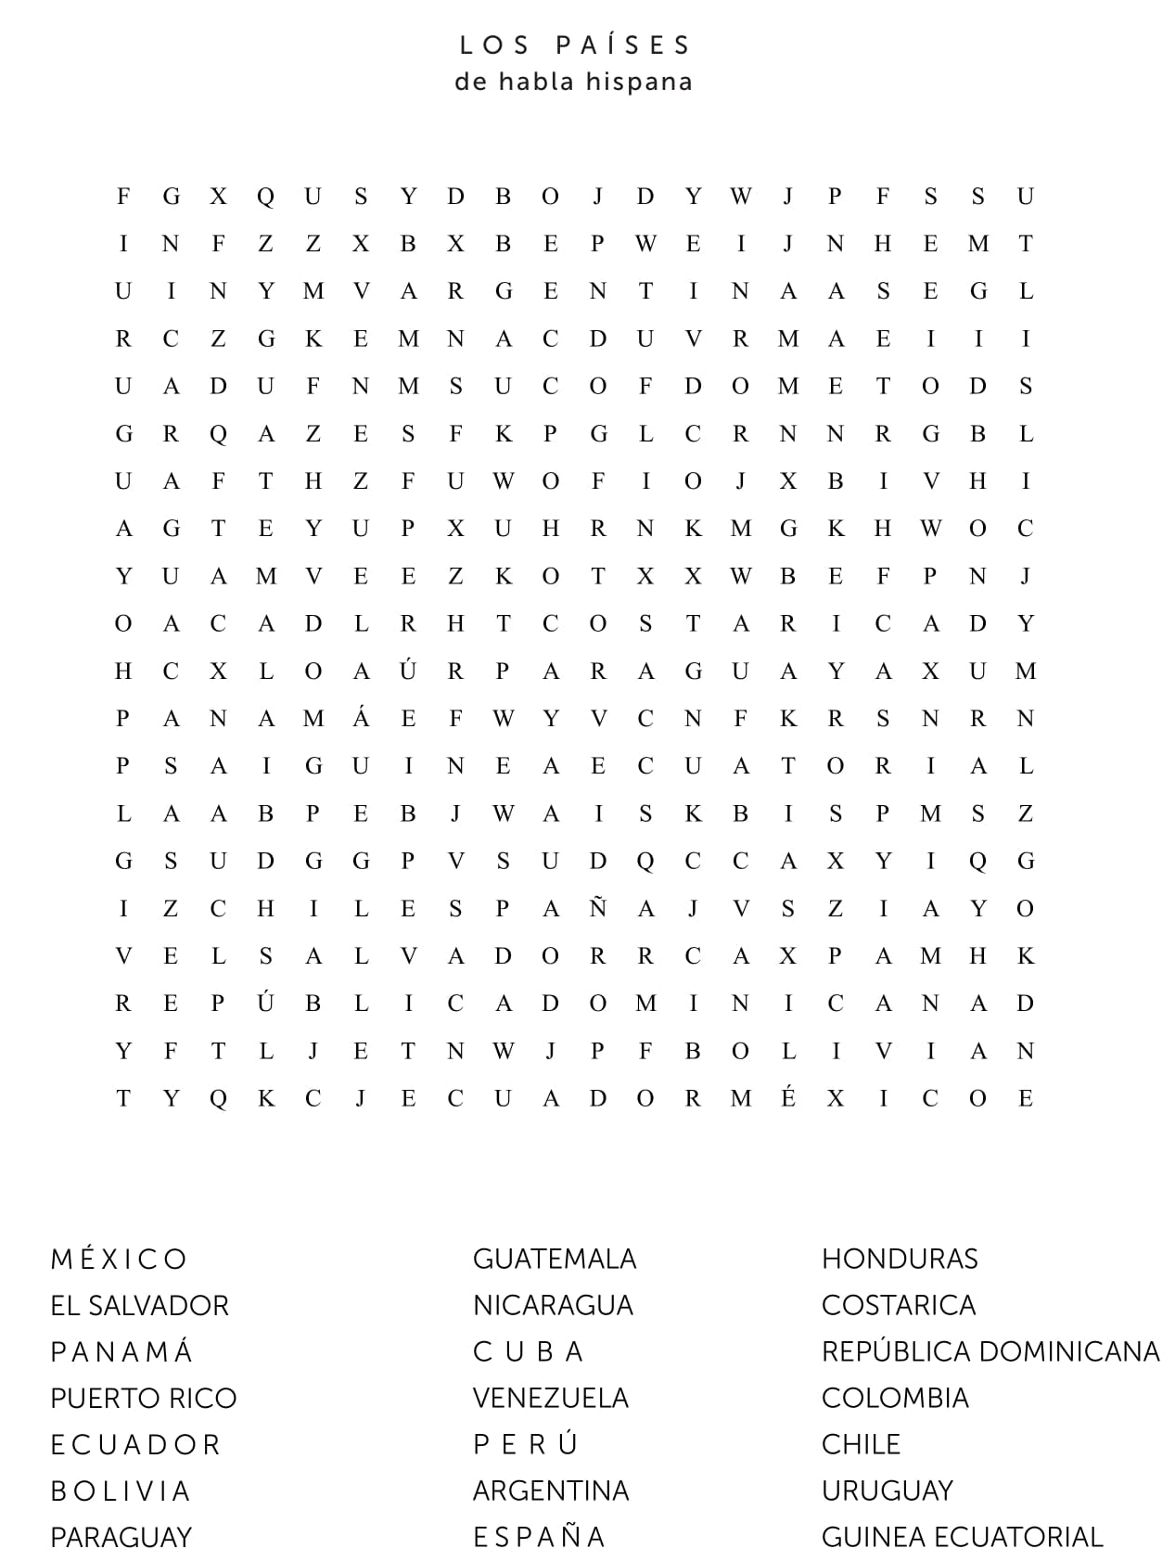
Extra Maths! Problem solving and reasoning questions
Carnival maths!
Bean Bag Buckets
You have 3 beanbags. Each bag in is thrown into a bucket. More than one bag can go into a bucket. Each bucket is worth a fraction of an amount
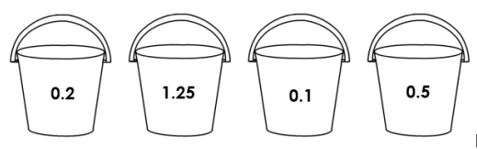

What could you score? Answer using decimals.
Then, write your scores as a fraction!

The hammer hit
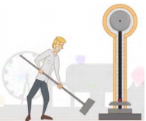
One of the activities to guests at the carnival is The Hammer Hit. You scored between –20 to 20 for each hit.
These are the scores for Tim’s go:
1) – 11
2) 2
3) - 5
4) 7
What was Tim’s final score?
Can you set a similar question for someone at home or at school?

Clown race
The clowns are having their annual relay race. These are the times, in minutes and seconds, for the Scruffy the clown’s team:
Scruffy: 11:07 Boffo: 20:37 Velvet: 14:12 Chester: 21:15 Sunshine: 16:43

How long in total did it take them to finish the race?

